PDPTool User Guide

This document is a brief introduction to pdptool, a MATLAB application for connectionist or PDP models. The first section gives a quick overview of the software and its functionality. The second section provides a description of the application’s menus, dialog boxes and display windows. This is a work in progress, so we will be updating the software and the documentation frequently as we make changes and upgrades.

Introduction

Pdptool is a neural network simulator which implements the models described in Parallel distributed processing: Explorations in the microstructure of cognition (Rumelhart, D. E., McClelland, J. L. and the PDP research group. (1986)), as well as several other models that have been developed since that time within the PDP framework. This tool has been designed as a teaching aid for Parallel Distributed Processing courses, and for implementing variants of existing models for research. The software is intended for use in conjunction with the PDP handbook (Second Edition) which provides theoretical background and helps the reader in exploring simulation programs using a number of prepared exercises.

System Requirements

This application was created in MATLAB some years ago. In initially there were platform compatibility issues but at the current time the software appears to run on Windows XP, Windows 7, Mac OSX and Linux environments using recent versions of MATLAB. A stand-alone version is available for Windows and Mac OSX as well. Further information is available through the Stanford PDPLab Resources page, and the on line version of the PDP Handbook, both accessible at the following url: http://www.stanford.edu/group/pdplab/resources.html

Usage

PDPtool can be run with or without graphical window capabilities. We use the term ‘gui’ mode (graphical user interface mode) for running with graphical windows and ‘nogui’ mode otherwise. In gui mode, the user can perform actions interactively by clicking on interface objects like menu items, pushbuttons etc. Each of these actions have corresponding function calls that have to be used in user-written script files when running pdptool in nogui mode. e.g. Clicking on the ‘Load Script’ button in the PDP window helps the user to select and load a network script file; alternatively using the command ‘loadscript’ with correct arguments performs the same action non-interactively. We will describe each of these functions below with their appropriate syntax.

PDPtool simulates different classes of models which are described in each of the chapters in the PDP handbook. The user-interface of the application in gui mode, options for setting network properties etc., are governed by the network type of the most recently loaded network.

Network files

Pdptool uses different kinds of files for setting up and running neural network models. Following are the associated file types for every network.

<File>.net: This file describes the configuration of the network. It must have the network defined in a matlab structure variable called ‘net’. Network pools or layers are to be defined as an array of structures called ‘pool’. The bias pool is always the first pool with 1 unit having activation value of 1.0 (for all networks except pattern associator for which the bias output is 1.0). The bias pool need not be explicitly defined in the file.

<File>.tem: This file specifies the appearance and layout of the network viewer display. This is a set of matlab function calls that specify display properties of network variables that have been selected for display. This file is created by pdptool throught the gui when the ‘Set display template’ module is invoked by the user to select and assign positions to desired network objects and then saved for future use.

<File>.pat: Pattern files for providing external input to the network pools. Several kinds of pattern files are recognized. The simplest types are files containing a list of input patterns only (used with iac, cs and cl types of network) and files containing a list of input-target pairs (used with pa and bp types). More complex pattern files are used with srn and rbp. For the simpler cases, each pattern specification consists of a name, followed by a sequence of floating point numerical values, corresponding to input pattern values, and, for pa or bp, target pattern values.

<File>.wt: This file can be used for connection weights in networks that have matrix of weight values in the projection structure of their pools. The ‘Save weights’ module gives the user options for saving weight matrices. The ‘Load weights’ module loads the weights into the current projections. The file can be in binary or text mode. In both modes, the file carries information that uniquely identifies the weight matrix in terms of the pool and projection it belongs to. In text mode, the file is in ascii format, with each weight array preceded by two separate lines. The first line specifies the pool index, and second one gives the projection index. In binary mode, the weights are saved in a matlab array of structure having fields ‘weight’,’pooln’,’projn’.

<File>.out: This file is used for saving the network state periodically during training and/or testing. The ‘Manage output logs’ module allows the user to specify network objects whose values need to be logged at specific intervals. This can also be written out in binary or text format. In binary form, the file is a .mat file consisting of rows of values, one row for each write operation, each row having entries of network state values in the order specified during the log setup. In text format, the first line is a header with the names of the network objects that are logged below it. There is one row of values separated by white space, per write operation.

pdplog<n>.m: This is a matlab log file which is created in the user’s current directory for the current network session. The program generates a filename pdplog<n> where n is a numerical suffix that assigns a unique name to the log file. If the ‘log network’ flag is set, the program records every function call and command line operations into this file, as long as the session is active. The purpose of this file is to facilitate the replication of the network state without having to re-run every operation. To enable logging operation, the command history preferences MUST be set to save after every command.

Using the pdp window to create and start networks through the gui.

The main pdp window is the main application window. It is the hub of all network activities. This window is displayed when the user first invokes the pdptool by typing ‘pdp’ or ‘pdptool’ on the matlab command window. Before doing this, users must add the pdptool directory to their path environment variable via MATLAB’s File->Setpath … menu item or using the addpath matlab command. Closing the main pdp window or exiting from this will automatically terminate every operation in the current session.

The pdp window has several menu items and three push button controls.

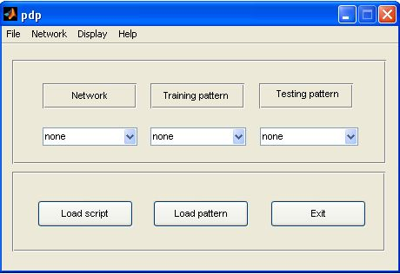

The Load script button opens a file dialog box to allow the user to select a .net file in the chosen directory. These files are generally created through the Network/Create menu item, described below. Once the file is loaded, the network name appears in the network pop-up menu. (Another way of loading scripts is invoking ‘pdp’ with command line argument. This can be a comma-separated list of .net files which are loaded into the application in the order of their appearance in the argument list. e.g typing ‘pdp(‘xor.net’,’pa.net’)’ or simply ‘pdp xor.net pa.net’ (without quotes) loads both networks into the application. The last loaded network script will be recognized as the current network which will be available as a workspace variable ‘net’.) The networks are identified by their names and listed in the network pop-up menu of the pdp window. The current network can be changed by selecting from the list of networks.

The Load pattern button allows a .pat file to be selected and loaded. The pattern file name gets loaded onto the ‘Training patterns’ and ‘Testing patterns’ pop-up menu. The network’s training and/or testing set can be changed by selecting from these pop-up menus.

The exit button terminates the application.

Menu items: There are five menu items in the pdp menu bar. These are discussed below.

File menu – This provides basic text editing and logging options. The menu items are

New
Opens a new document in the matlab text editor.

Open
Presents the file open dialog box for selecting a file to load in the matlab text editor.

Log network
This menu item is checked, by default. Un-checking it will stop network operations
from being recorded in the pdplog files.

Exit
Terminates application and closes all open windows.

Network Menu: This contains several menu items for examining and controlling the network’s parameters and state.

Create…
This invokes the network create module for setting up a network from scratch. It is described below in detail.

Set Training options
This presents a window with the network training parameters that can be examined and/or changed by the user. The parameters selected for presenting are based on the network type of the currently loaded network. When the mouse pointer is moved over each parameter, a pop up appears with a brief description of its use and function.

Set Testing options
This presents a window with the network testing parameters that can be examined and/or changed by the user. The parameters selected for presenting are based on the network type of the currently loaded network. When the mouse pointer is moved over each parameter, a pop-up appears with a brief description of its use and function.

Delete
This contains submenu items ‘Network’, ’Training pattern’, ‘Testing pattern’. Selecting ‘Network’ will delete the current network, remove the corresponding network name from the network pop-up menu and make the next item in the list, if any, the current network. Similarly, selecting Training or Testing pattern will delete the selected pattern file and remove the corresponding item from the pop-up menu.

Launch network window
This opens the network viewer window. This is described in detail below.

The next several functions are usually accessed through the network viewer window but are also available in the network menu:

Load weight file
This presents the file open dialog box to select the appropriate .wt file.

Save weight file
This opens a small window that allows users to specify the name and location where the file should be saved. It also presents a checkbox to indicate binary or text mode of saving.

Newstart
This reseeds the random network generator and then resets the network.

Reset
This resets the network with the current network seed value.

Manage output logs
This invokes a window that allows the user to set output writing options. This is described in detail below.

Display Menu: This contains three menu items that enable the user to create, load and edit display templates for the current network. The menu items are –

Select display items
This presents the user with a window that contains a list of network objects that can be selected and added for use in the display template. This window is described in detail below.

Load Template
This presents the file open dialog box for loading a <.tem > template file.

Edit display parameters
This presents a window that allows user to edit the display template size. It shows the current values of template rows, columns and cellsize and presents a separate panel for editing these values. Changing these values preserves the relative size and distance of individual display components in the network viewer without the user having to edit each template object in the .tem file. If the network viewer window is already open, user must close it and launch it again to see the applied changes, by selecting ‘Launch Network viewer’ menu item from the ‘Network’ menu of the main pdp window. The changes to the display are by default, applied only to the network viewer in the current session. The new values can be saved into file for future use by checking the ‘Save to File’ checkbox. The default file name is the current template file associated with the network. User can save changes into another file without overwriting the existing .tem file by clicking on the ‘Change..’ push button and selecting a new file name.

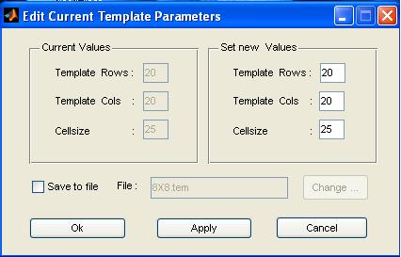

Application Windows

Network Setup: This window is displayed when the menu item ‘Create ..’ is selected from the Network menu. It presents an edit box for the network name and a pop-up menu for selecting the network type from a list of types. It has a ‘Define’ panel with a pop-up menu for specifying pools and projections, but these remain disabled till the user selects a network type to start with. Once the network type is selected, the pop-up menu with network types is replaced by a static text field. The ‘Define’ panel is now enabled and ready for use. A toolbar is made visible with three buttons in the top left corner of the window (see below). Moving the mouse over each button will show tooltip strings that indicate their purpose.

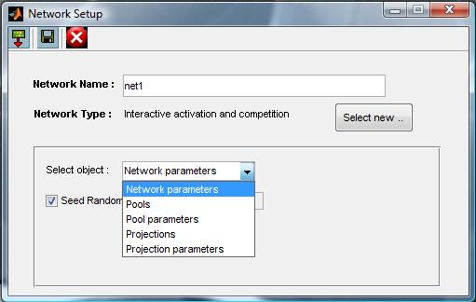

The network set-up process creates a script that can later be used to construct a network. The first toolbar item is a toggle button which shows or hides the script in progress. When the toggle state of the button shows a red arrow pointed down, the button can be clicked to reveal a panel at the bottom where a script is being written out for the user. This panel can be hidden by either clicking on the close button on the top right of the panel or by changing the toggle state of the toolbar item to ‘Hide script’. The second toolbar item saves the network. After the network has been defined the user must click on this item to save the script into a .net file. After it is saved the newly created network will become the current net and its name will be the selected item in the network pop-up menu of the pdp window. The third toolbar item aborts the network creation process and terminates the network setup window.

Pools and projections can be specified by clicking the Pools or Projections item from the list of objects in the pop-up menu. Options for pool or projection definition and the various network specific parameters are made visible at the bottom of the window on selecting the appropriate list items. For defining pools, the mandatory parameters in the pool setup panel are Name, Type and Nunits corresponding to the pool variables, ‘name’, ’type’, ’nunits’. A Pool type must be selected from a pop-up menu labeled ‘Types’. This lists all available pool types like ‘input’, ’output’, ’hidden’ etc depending on the network type that has been selected for definition. Other values that need to be filled are pool name and number of units. Once this is done, the user must click the Add button to add the pool to the network. At any point, to view/edit the pools previously defined, the user can right click on the Name edit box and select ‘Edit’. This will replace the edit box with a pop-up menu of all currently defined pools, selecting a pool name will show the number of units and the pool type that was set for it which can then be edited if desired. In edit mode, the ‘Add’ button will be replaced by a ‘Done’ button. Clicking the ‘Done’ button completes the edit process. A pool’s name cannot be changed in edit mode. However, one can remove an already defined pool completely by right clicking on the Name pop-up menu after selecting the pool to be deleted while in edit mode and selecting ‘Delete’. Pools cannot have same names, and any attempt at defining exactly similar names will produce an error message. It is a good practice is to define all desired pools before starting to define pool parameters or projections.

Once the pools have been defined, the user can select ‘Pool parameters’ from the ‘Select Object’ list of items. For certain types of network, this allows unit names to be read in from a file or set by hand. When ‘Set by hand’ option is selected, the edit box adjacent to the pop-up menu is available for user to type out a comma separated list of unit names. User must press ‘Enter’ key after typing unit names to add the unames parameter to the pool. If the list in edit box does not match the pool size of the selected pool, the unames parameter will not be set and an error message will be thrown on the MATLAB command prompt.

Projections are defined by selecting ‘Projections’ from the ‘Select Object’ pop-up menu. This presents a ‘Sender’ list containing the default pool ‘bias’ and all the pools already defined in the pool setup process. The ‘Receiver’ list contains all pools except the bias pool. A projection is defined by selecting a pool from the sender list, one from the receiver list and then specifying the connection weight constraints between them. Constraint type can be selected from a pop-up menu of items. Available items vary depending on the network being set up. If constraint type is ‘Scalar’, a scalar value can be typed into the edit box labeled ‘Value’. Clicking on the ‘Add’ button will add the projection to the ‘receiver’ pool structure. For network types with fixed (as opposed to learned) connections (iac and cs), the user can select ‘read file’ as the constraint type to have the network read the fixed connection values from a file containing a series of lines each containing a series of entries separated by white space. These can be real numbers, or any of these three shorthand entries: . (0), + (+1) or – (-1). Each row corresponds to a receiving unit and each column corresponds to a sending unit, so the value in row 2 column 4 specifies the weight to unit 2 in the receiving layer from unit 4 in the sending layer. However, if the ‘transpose file’ constraint type is selected, the matrix is transposed. This allows the same file to be used to specify bi-directionally symmetric connections. For example if vispool has 5 units and hidpool has 3 units, a file containing 5 lines each with three entries can be read using ‘read file’ to specify weights for the projection to vispool from hidpool and using ‘transpose file’ to specify weights for the projection to hidpool from vispool.
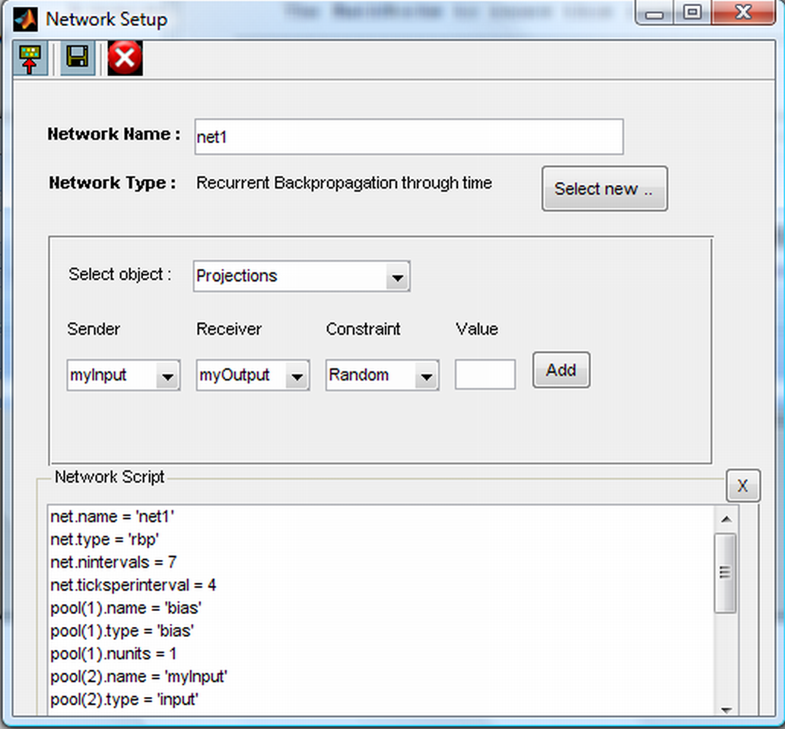

For certain types of network, the user can specify projection level learning rates by selecting ‘Projection parameters’ from ‘Select Object’ pop-up menu and choosing from the list of projections already defined. Projections in the list are represented as ‘sender_pool→receiver_pool’. User can select the desired projection and then edit the ‘lrate’ edit box to specify a learning rate value for that projection. The default behavior is to use the global lrate parameter from the training options for every projection.

If at any point the user wishes to change the network type, the setup process must start from scratch. This can be done by clicking on the ‘Select New..’ push button control. This will abandon the setup process and bring the network setup window to its original state.

Select display Items: This window is displayed when the user selects ‘Select display items ..’ from the Display menu of the pdp window. This window is divided into two panels - left panel gives an explorer-like tree view of the network structure and right panel is a list of display items selected and added from the list on the left or items that have been loaded from the current template file, if any.

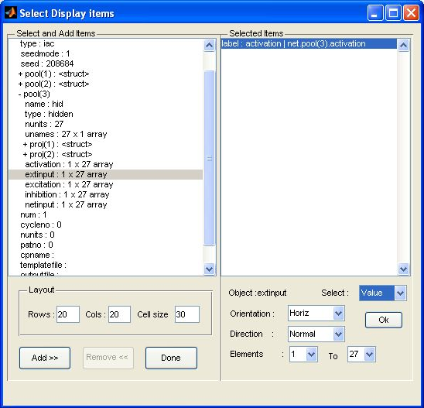

There are ‘Add’ and ‘Remove’ buttons to manipulate the selected list. After selecting a network object and clicking ‘Add’ button, the module allows the user to specify if the object name has to be saved as a label for display or the object value has to be saved as a display component. A ‘label’ type display object is not subject to change during screen updates, and is simply the name of the object. The ‘value’ type object specified that the variables value will be displayed. When the user selects this type, the program presents options depending on the type of variable, e.g., string, scalar, vector, matrix. Vectors and matrices as display objects can have other properties like orientation, direction and the display components can be sub-sets of their size. Menus to allow user control over these aspects of such display objects are provided. Once the properties for an individual display object are determined, it is added to the list on the right panel on clicking the ‘OK’ button. All display objects are selected and added in this manner. There are edit boxes for specifying the row and column size of the template as well as the unit cell size. Users should check carefully that they have specified desired labels and values correctly before proceeding.

When the user has the final list ready, the ‘Done’ button can be clicked to invoke the ‘Set Display’ window that allows the user to create the template by hand. This window has a list box on the left, with items that were selected in the select process just done. On the right is a grid with rows, columns and cell size as specified in the select process. Selecting an item on the list, followed by clicking on the desired location on the grid places the item at the selected position. The objects can be dragged and dropped till the user is satisfied with the layout. The grid size can be increased or decreased by resizing the window.

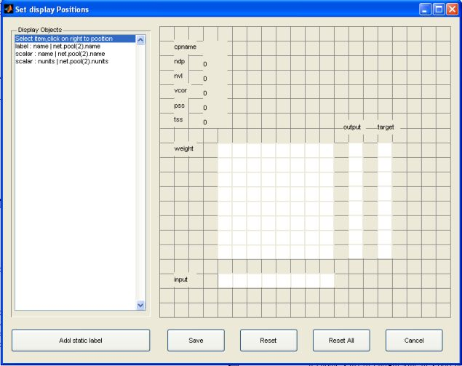

This window has four push button controls too. The ‘Add static label’ button allows the user to create labels that are not associated with any network object. Clicking the ‘Reset’ button will move the selected objects on the grid back to the main list on the left. ‘Reset All’ will move all the items back to the list. ‘Cancel’ will terminate the window without saving anything. ‘Save’ will save the template in a <.tem> file. Once the file is saved, it is still possible to go back to the Display menu, select additional display items, position these, and then re-save the template file.

Network viewer: This window is invoked when the menu item ‘Launch network viewer’ from the Network menu is selected. This action can be taken after a network and a template have been defined, and these will be loaded automatically. This window has three panels – a control panel that contains various user-interface control objects for interactively running the network processes, a layout panel that displays the template objects as specified by the user in the current template, and a patterns panel that shows a list of training or testing patterns for the current network. The size of the entire window is recalibrated according to the template size specified.

The control panel is further divided into two panels, the Train panel and the Test panel. For networks which do not learn, like ‘cs’ and ‘iac’, the network viewer appears with the ‘Train panel’ disabled and grayed out. The user can specify the frequency of screen updates during training or testing by editing the value in the ‘Update After’ edit box. The granularity of updates can also be specified by selecting from the ‘Update After’ pop-up menu. The granularity range differs for different network types. For instance for ‘pa’ network, display granularity can be epoch, cycle or pattern while ‘cs’ type of networks can have display granularity of cycle and update.

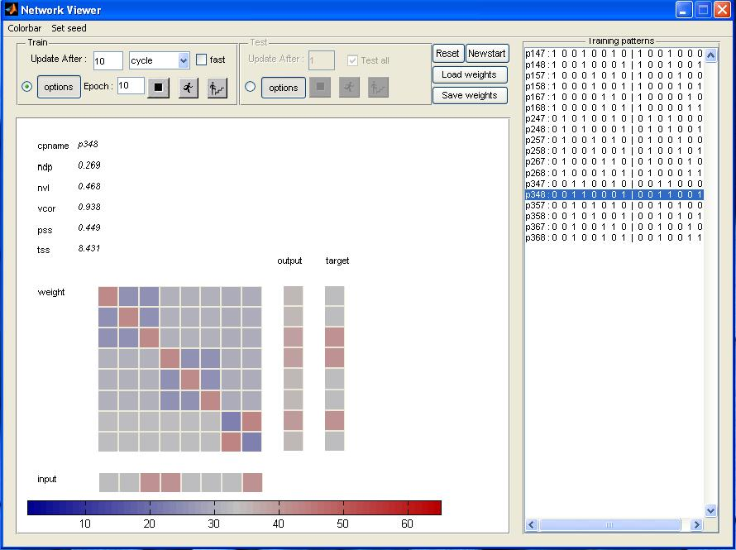

The network processes can be initiated and controlled by the user, using 2 sets of three buttons in each of the panels. The button with the ‘run’ icon executes the network process (train or test) updating the screen according to the frequency and granularity specified till it completes the total number of process iterations. The button with the ‘step’ icon allows interactive display update. It steps through the network process, and pauses after each frequency step and waits for user action (by clicking the step button again). The button with the ‘stop’ icon enables user to pause the current ‘run’ or ‘step’ process. After pausing with the stop button, the process can be resumed from the break point by clicking run or step again. The train and test panels have a push button control called ‘Options’. These display the training or testing parameters for the current network. The control panel also contains buttons for newstart, reset, load weights and save weights. These essentially perform the same operations as the network menu items with the same names (described above) and are available in the network viewer also for convenience.

The train panel has a checkbox called fast. When checked, this runs the train process in fast mode. Currently, we have fast mode available only for rbp and bp type of networks. This gives the advantage of a speedier training process(at least five times faster than regular runs), but does not support several features like stepping through network runs or finer granularity of display updates and output logging. In the fast mode, only epoch level display updates and logging are permitted.

The layout panel holds all the network objects arranged according to the display template. It can also contain a colorbar to display the color scale used for shading the display objects. The colorbar can be turned on or off by checking the ‘Colorbar’ menu item.

The patterns panel holds testing and training pattern list. It makes the appropriate list visible, depending on the network process currently in use. For instance, the training patterns will be made visible when the network is training and testing patterns will be made visible when testing process starts.

Set write output options: This window is invoked when the ‘Manage output logs’ menu item is selected from the network menu of the pdp window. This window allows user to create a new log or edit an existing log for writing network output values. New log is created when user provides a base name for file and clicks on ‘Create new’ button. It creates a file with .mat extension when the ‘Binary’ checkbox is checked and a .out file when the ‘Binary’ checkbox is unchecked. The program generates a unique file name by appending a numerical suffix to the base name provided by the user. e.g if ‘xorlog’ is the base name supplied and extension is .mat , then the file name generated is xorlog1.mat if the current working directory has no file with the provided base name. If xorlog1.mat already exists, the new file name generated will be xorlog2.mat.

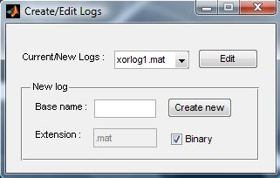

If log files for the current session exist, the pop-up menu labeled ‘Current/New logs’ shows a list of opened logs. Selecting an existing log file name from the list and clicking ‘Edit’ opens a new window called ‘Set write output options’.

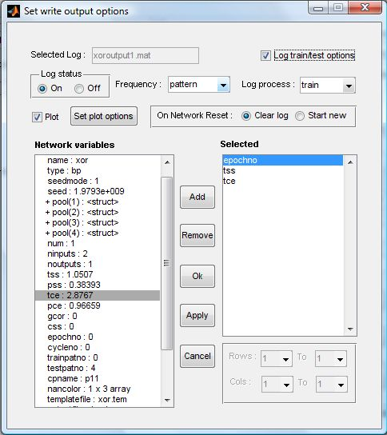

This window shows the parameters associated with a selected output log and allows user to edit or change the settings. The log status can be turned on or off to enable or disable logging as and when needed during the course of network run. A frequency pop-up menu provides the flexibility of controlling intervals of writing operation. A log process pop-up menu allows a choice of logging just the test or train process alone or both. There is a checkbox labeled ‘Log train/test options’. When checked, this enables recording all the training/testing parameters in the output log file along with the network output values. There are two panels for selecting the network objects for logging. The left panel presents the network structure in an explorer-like tree view. Selecting a network variable, followed by clicking on the ‘Add’ button will add an item to the ‘Selected’ list. When selected item is a vector or matrix, user can specify a subset of rows and columns of values to be logged by selecting the start and end index in the Rows and Cols list. Selecting an item on the right hand side list and clicking on the pushbutton labeled ‘Remove’ will delete the item from the selected list. Clicking on ‘Ok’ or ‘Apply’, after the desired network variables have been selected for logging will apply the changes to the selected log. The ‘On Network Reset’ radio button allows user to select the logging behavior when network is reset. When ‘Clear log’ option is selected, the network output file will be deleted at the time network is reset and when a fresh run is executed after reset, output will be logged onto a new file with the same name. ‘Start new’ option preserves output files when network is reset and when network is rerun, creates a new file for logging. The new file name is derived from the user specified base name of file such that all new logs have a suffix of ‘_<numerical_index_of_file> e.g. if base name is xorlog1.mat, new logs are xorlog1_1.mat, xorlog1_2.mat when output is logged (with Start new option) after network resets. The ‘Plot’ checkbox enables ‘Set plot options’ button, clicking on which opens up another window for setting graphical plotting of output values.

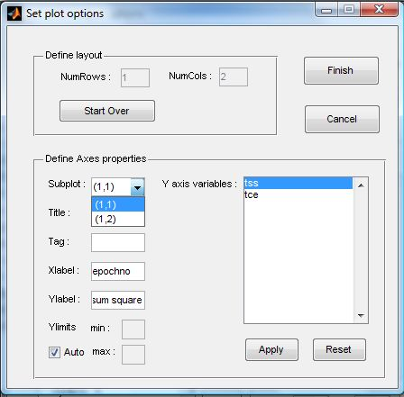

The ‘Define layout’ panel edit boxes for providing number of rows and number of columns of subplots when multiple graphs have to be plotted. In the ‘Define Axes properties’ panel, each subplot identified as (row,column) pair can be selected from the pop-up menu and properties for the selected subplot can then be set. All the options are applied and window closed when the ‘Finish’ button is selected.

Command line functions and usage with no gui

In this section we describe the function calls with their syntax for all the network processes above. Every action performed interactively has a corresponding direct function call. Users can familiarize themselves with the syntax of these functions by reviewing the pdplog files that contain function calls corresponding to the gui actions. These function calls must be used when running pdptool in nogui mode and may also be used when running pdptool in gui mode. Even in gui mode, typing out a command instead of interactively pointing, clicking and selecting with the mouse for every action, might be useful, and repeated sequences of steps can be saved as scripts in files. For this case however, the application must be initialized and the pdp window must be open for these function calls to work. For nogui, non-interactive mode, these functions must follow the command ‘pdptool nogui’.

Load network script - This is achieved by the function ‘loadscript’. This must be the first function call after pdptool has been setup. All other functions must follow this as network definition happens in this step.

Function signature: (a) loadscript(‘<filename>’)
(b) loadscript (‘file’,’<filename>’)

Syntax (b) is rarely used and is available here only to adhere to the convention of using ‘property-value’ pair specification used in MATLAB. Using <filename> alone is sufficient for this. <filename> should be a valid network script file with .net extension. If <filename> is not in the current directory, the entire path must be specified. <filename> should be within single quotes as it is expected to be a string value.

Load pattern files – This is achieved by the function ‘loadpattern’. Arguments to this must be provided as property-value pairs. It accepts three properties - 'file', 'setname' and 'usefor'.
Function signature :
loadpattern ('file',<'filename'>,'setname', <'setname'>, 'usefor', <'train/test/both/none'> )

Property Value_type Acceptable_values Default_value
file String A valid file name(.pat) empty string
setname String Any string Name of file (without extension)
usefor String train, test, both, none none

- 'train' for 'usefor' property will set training set to setname. 'test' will set testing set to setname. 'both' will set training and testing set to setname.
- Short forms of property names work as well as long forms.
e.g. loadpattern ('f','f1.pat','set','myset','use','train') works the same way as loadpattern ('file','f1.pat','setname','myset','usefor','train'), as long as property name collisions do not happen.
- Order of property-value pair is not important as long as property names are followed by their respective values.

Load Template File – The function name for this is ‘loadtemplate’.
Function signature: (a) loadtemplate (‘<filename>’)
(b) loadtemplate (‘file’,’<filename>’)

Syntax (b) is rarely used and is available here only to adhere to the convention of using ‘property-value’ pair specification used in MATLAB. Using <filename> alone is sufficient for this. <filename> should be a valid display template file with .tem extension. It must have been created manually with setdisplay function calls or created interactively using ‘set display items’ module (described above) during a prior gui run. If <filename> is not in the current directory, the entire path must be specified. <filename> should be within single quotes as it is expected to be a string value.

If called when running pdptool in nogui mode, this function call will have no effect.

Launch network window – The function call for this is ‘launchnet’.

Function signature: launchnet; (no argument list)

This function will bring up the network viewer when running pdptool in gui mode. In nogui mode, this function call will have no effect.

Set Training options - This is achieved by the function settrainopts. Arguments to this must be provided as comma-separated property-value pairs. Property names are the network training parameter names and these are different for different network types. e.g To set nepochs to 10 and learning rule as hebbian ,in the training parameters for ‘pa’ network type, use the function call – settrainopts(‘nepochs’,10,’lrule’,’hebb’);

Set Testing options - This is achieved by the function settestopts. Arguments to this must be provided as comma-separated property-value pairs. Property names are the network training parameter names and these are different for different network types. e.g To set ncycles to 20 and estr to 0.4 ,in the testing parameters for ‘iac’ network type, use the function call – settestopts(‘ncycles’,20,’estr’,0.4);

Load weight file - The function name for this is ‘loadweights’.
Function signature: (a) loadweights (‘<filename>’
(b) loadweights (‘file’,’<filename>’)

Syntax (b) is rarely used and is available here only to adhere to the convention of using ‘property-value’ pair specification used in MATLAB. Using <filename> alone is sufficient for this. <filename> should be a valid weight file with .wt extension.If <filename> is not in the current directory, the entire path must be specified. <filename> should be within single quotes as it is expected to be a string value.

Save weight file - The function name for this is ‘saveweights’. Arguments to this function must be provided as property-value pairs. It accepts 2 properties - 'file', 'mode'.

Property Value_type Acceptable_values Default_value
file String File name (.wt) pdpweight1.wt etc.
mode String binary,text binary

- Short forms of property names can be used.
- mode value can be shortened upto single letters (‘b’ or ‘t’).
- Order of property-value pair is not important as long as property names are followed by the their respective values.

Manage output logs – This is achieved by function ‘setoutputlog’. Arguments to this function must be provided as property-value pairs. It accepts six properties - 'file', 'process', 'frequency', 'status', 'writemode', 'objects'.

Property Value_type Acceptable_values Default_value
file String File name (.mat or .out) log1.mat
process Cell array of strings {'train'},{'test'} {'test'} {'train,'test'}
frequency String pattern,epoch etc pattern
status String on,off off
writemode String binary, text binary
objects Cell array of strings comma-separated {}
names of network
objects, enclosed in a
pair of braces.

e.g setoutputlog ('file', 'net1log1.mat','process', {'train'},'frequency', 'pattern','status', 'on','writemode', 'binary','objects', {'pool(3).input','pool(3).output','pss'})

This sets output log to a file called net1log1.mat to record in binary mode ,values of the network objects pool(3).input, pool(3).output, and pss after processing every pattern during training. The logging is turned on as shown by the status property .

This same logging can be ,if required turned off at any time by using the command,
setoutputlog ('file', 'net1log1.mat','status', 'off'); Other properties can be manipulated in a similar manner.

- Short forms of property names can be used.
- Order of property-value pair is not important as long as property names are followed by their respective values.

Running the network – This is achieved by the function ‘runprocess’. Arguments to this must be provided as property-value pairs. It accepts nine properties - 'process','mode','granularity', 'count', 'pattest', 'alltest', 'range', 'nepochs', 'fastrun'

Property Value_type Acceptable_values Default_value
process String train,test test
mode String run,step run
granularity String epoch,cycle pattern
(depends on net type)
count Integer non-negative 1
pattest Integer 0,1 0
(for cs,iac only)
alltest Integer 0,1 0
nepochs Integer positive integers 1
(for pa,bp,srn,rbp and cl)
range Matrix depends on net type [ ] (empty matrix)
fastrun Integer 0,1 0

- For nogui option, display parameters like mode, granularity and count are redundant and need not be specified.
- Short forms of property names can be used. 'proc', 'gran' etc.
- Values that are of String type and have a finite set of possibilites can also be shortened.e.g runprocess('proc','train', 'gran','pat', nepochs,10); will run the train process for 10 epochs and update the network viewer after processing every pattern.
- Order of property-value pair is not important as long as property names are followed by their respective values.

Reset the network – This is achieved by the function <type>_reset. <type> is the network type of the network currently loaded. e.g . iac_reset will reset the network state for network of type ‘iac’, cl_reset for networks of type ‘cl’ and so on.

Newstart – This is achieved by the function ‘newstart’ (without any arguments).
Terminate the application – This is achieved by the function ‘pdpquit’. It clears all pdptool variables and exits from the application. It works for both gui and nogui mode. In gui mode, when pdpquit is called, all open windows are closed before the application exits.

? Versions of PDPTool before 2.06 automatically created bi-directional connections in iac networks, and the ‘read transpose’ option was not available. Automatic creation of bi-directional connections was depreciated because it created confusion and limited flexibility. To check which version you are using, select Help/about’.

