Lab Six: Profile Plots, Repeated-Measures ANOVA

Lab Objectives
After today’s lab you should be able to:

- Convert data from broad to long form.
- Fill in missing data with LAST OBSERVATION CARRIED FORWARD (LOCF).
- Plot individual and mean profile plots.
- Check compound symmetry assumption of univariate repeated-measures ANOVA.
- Generate correlation and variance-covariance matrices for repeated measurements using PROC CORR.
- Use ANCOVA for end-point analysis in PROC GLM (broad form of data).
- Run repeated-measures ANOVA (univariate and multivariate) with PROC GLM (long form of the data).
- Interpret results from repeated measures ANOVA.
- Use PROC RANK to categorize a continuous variable into tertiles.
- Add additional features to make graphs fancier in PROC GPLOT.

SAS PROCs SAS EG equivalent
PROC GLM Analyze→ANOVA→Linear Models
PROC ANOVA Analyze→ANOVA→One-way ANOVA
PROC CORR Analyze→Multivariate→Correlations
PROC GPLOT Graph (→Line Plot)

LAB EXERCISE STEPS:

Follow along with the computer in front…

- For today’s class, we will be using the Lab 4 data (runners.sas7bdat). Goto: www.stanford.edu/~kcobb/courses/hrp262 and download the Lab 4-7 data.

- Open SAS EG: Start Menu→ All Programs→SAS Enterprise Guide

Name a library using hrp262 that points to the desktop, using point-and-click.

There are a number of datasteps that need to be done before working with the data. It’s much easier to do these in code, so we are going to code this part:
- Use Last Observation Carried Forward to fill in missing data on our repeated measurement of interest. This is easily done with a few lines of SAS code. In EG, click on Program > New Program. Type the following code:

data locf;
set hrp262.runners;
if bmc2=. then bmc2=bmc1;
if bmc3=. then bmc3=bmc2;
run;

This will create a new dataset called locf with missing bmc values imputed.

- Copy the locf dataset into a “broad” set with extraneous variables removed.
Add a unique id number for each subject (_n_ is an automatically generated SAS variable that is the row number of the observation—which totally depends on how the data are sorted).
When used BEFORE the set statement, the retain statement allows you to specify the order of variables in your dataset (column order). “Retain” is misleading, since non-specified variables will still be retained at the end of the dataset.

data broad;
retain id mencat1 stressf sitenum calc1 treatr dxa bmc;
set locf;
if bmc2=. then bmc2=bmc1;
if bmc3=. then bmc3=bmc2;
id=_n_; *create a unique id number to identify each subject;
keep id mencat1 stressf sitenum calc1 treatr bmc1 bmc2 bmc3;
run;
The keep statement keeps ONLY the variables specified.

- Then reformat the dataset into a “long” form (we will use both the broad and long forms of the data for this lab).

data long;
set broad;
Outputs 1 record for each bmc1; each bmc2; and each bmc3.
dxa=1; bmc=bmc1; output;
dxa=2; bmc=bmc2; output;
dxa=3; bmc=bmc3; output;
drop bmc1 bmc2 bmc3;
run;

- Click on each of the new datasets (broad and long) to view these forms of the data.

- Next, plot BMC over time by individual. Go to the BROAD dataset and click on Graph > Line Plot.

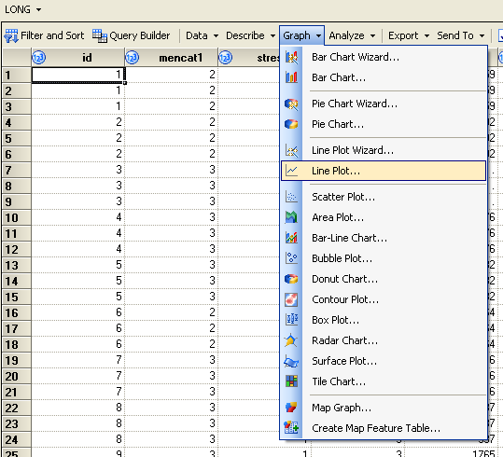

Choose Multiple line plots so that we can plot multiple observations on the same graph.

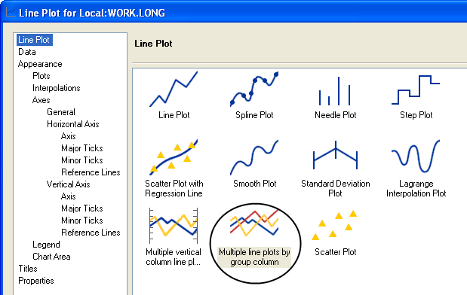

Under Data choose dxa as the Horizontal and bmc as the Vertical.

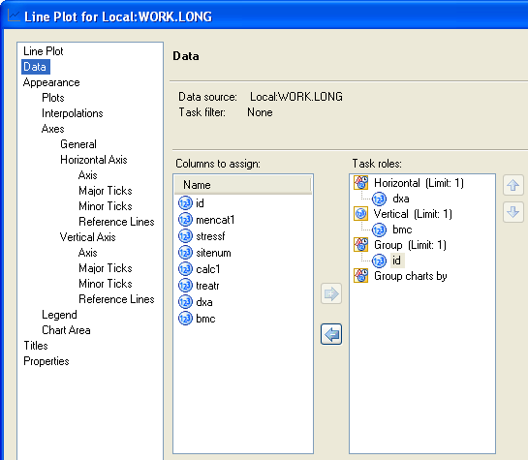

Under Legend, uncheck the box for show legend (you don’t want a legend for 78 participants!!).

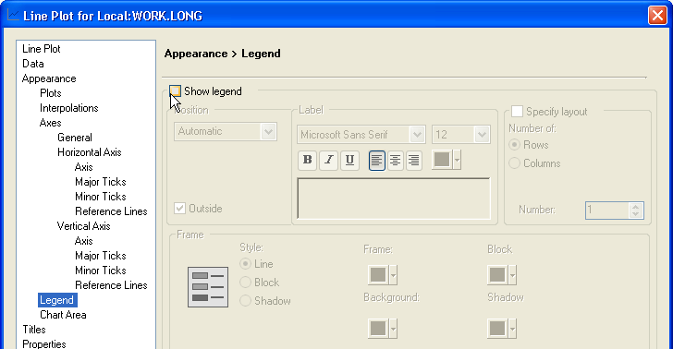

Click Run.

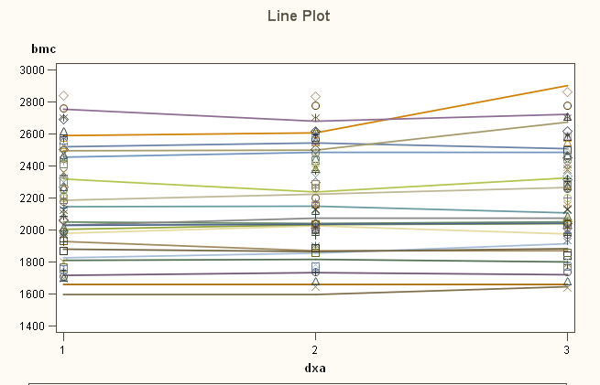

The resulting plot is not ideal as EG automatically decides which color to assign each of the 78 unique IDs yet only has 20 colors, so it eventually runs out of colors. It also uses the color white for some of the lines, which isn’t visible against the white background. There are 3 ways to fix this:

- Manually alter the color for each ID under the Appearance menu (painful if you have many observations!)
- Modify the code in EG using a repeat statement, to assign the same (or different) colors for each of the 78 IDs.
- Code the whole thing in SAS

To modify the code in EG, click on the Code tab and begin typing. When EG prompts you, click “Yes” to create a copy of the code. In the code, you can see that EG has created new symbols for each observation. We will add a repeat statement in the code for the first symbol1, and then comment out the rest of the symbols so they are not used:

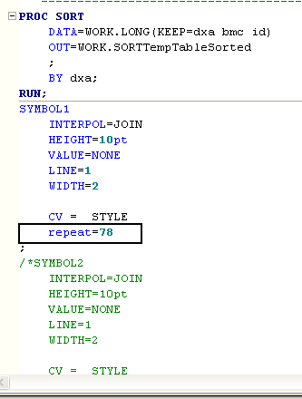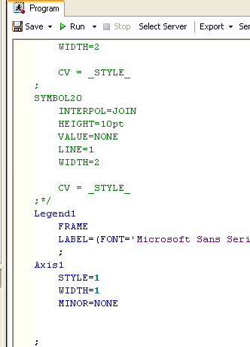

The resulting graph is much more attractive:
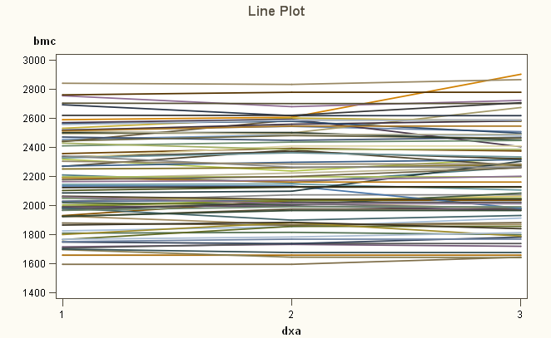

FYI, to do this entirely in SAS code:
You must sort before plotting, or lines will be connected incorrectly.
proc sort data=long;
Set global font type (ftext) and font size (htext) for graphics. Here, I’m choosing Old English font. See Appendix for other font types.
by id dxa;
run;

goptions reset=all ftext=oldeng htext=3; *change font type and size (Old English);
proc gplot data=long;
symbol1 c=black i=join v=none height=2 repeat=78;
plot bmc*dxa=id/nolegend;
Must specify one symbol/line for each individual in the dataset. Here there are 78 individuals. Repeat means that you want the first 78 symbols used to be identical.
run; quit;

Plot bone mineral content by dxa measurement by person.

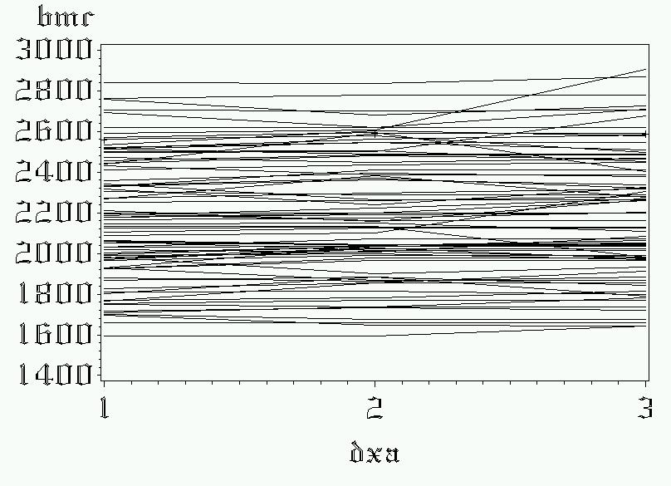

- It’s hard to make many conclusions with 78 lines cluttering the plot, so we can also plot a mean line rather than all 78 people. Plot by different categorical predictors. This will give mean lines (only), by group. Here I’m plotting by treatment group:

Select Multiple line plots by group column.
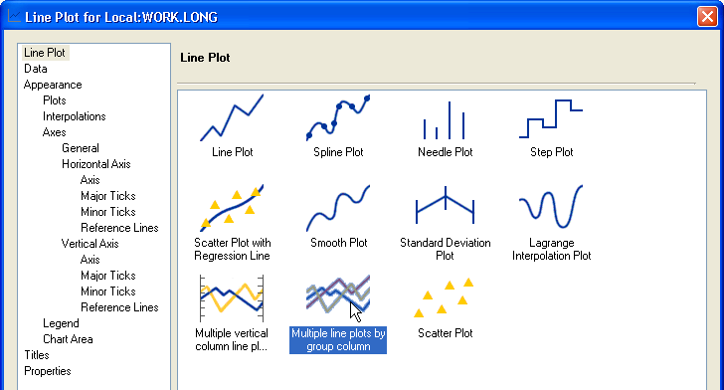

Under Data, select DXA for the horizontal axis and BMC for the vertical axis. Group by Treatr. Then Click Edit—we need to specify that we don’t want a separate line for people who have a value of treatr=. (missing).
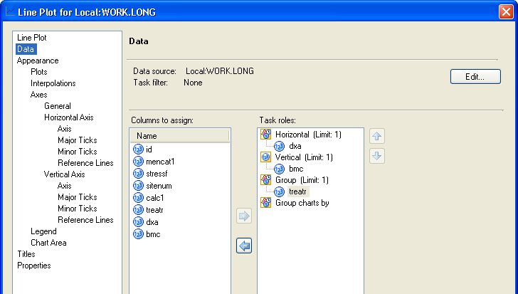

Only plot people where Treatr not equal to . (missing). Otherwise, you’ll get a third line on the plot for people with missing values!
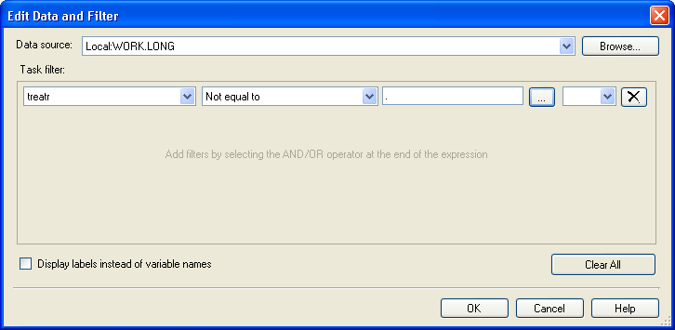

Under Interpolations, Choose STD. This asks for the means and standard deviations/standard errors to be plotted at each time point rather than individual points.
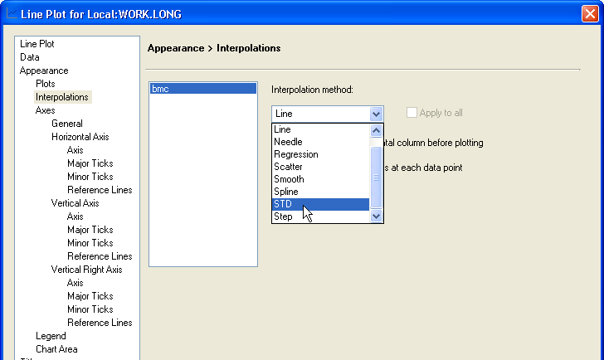

Then ask for +/- 1 standard error of the mean; connect the means with lines; and add “tops and bottoms” to the standard error bars (whiskers).
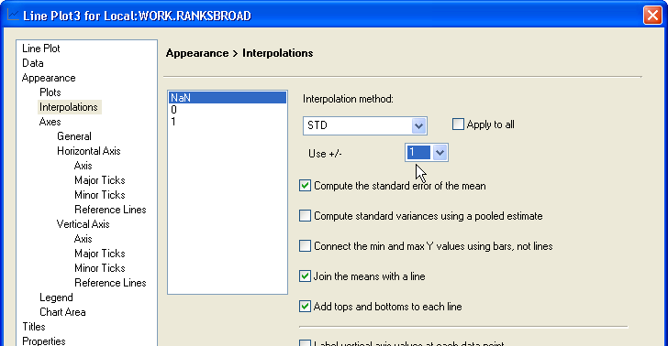

Under Horizontal Axis and Vertical Axis, add informative labels and angle the Vertical Label 90 degrees. Also play with changing the fonts for the labels:
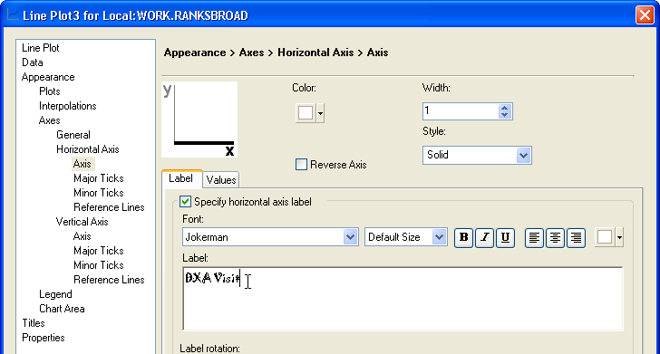
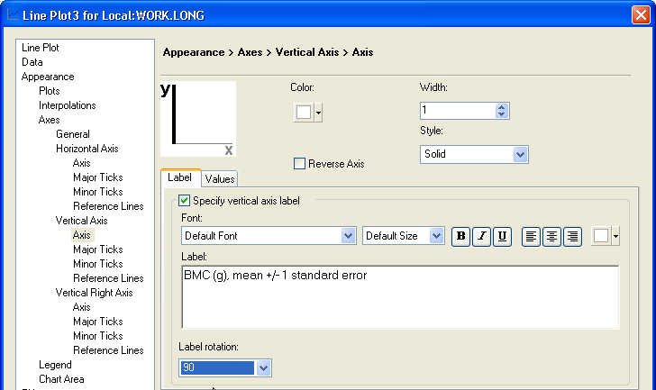

Under titles, add a title to the graph:
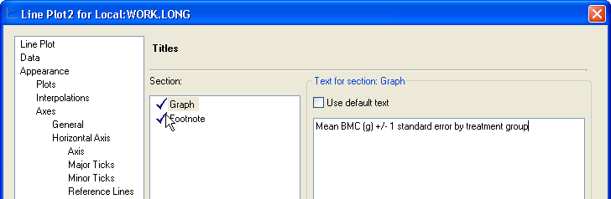

Click Run.

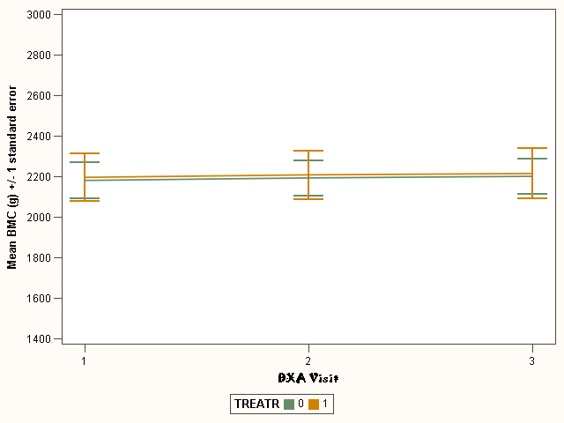

This doesn’t allow us to zoom in on the graph quite as much as I’d like. For example, there is a slight increase in BMC over time, but it’s hard to visualize here. So I’m going to modify the code a bit to zoom in on the graph, shrinking the vertical axis:

SYMBOL1
INTERPOL=STD1MJT
HEIGHT=10pt
VALUE=NONE
If you shrink the scale of the axes, you need to use mode=include; otherwise, individuals who are no longer within the scale of the graph will be excluded from the mean!
LINE=1
WIDTH=2
mode=include
CV = _STYLE_
;
SYMBOL2
INTERPOL=STD1MJT
HEIGHT=10pt
VALUE=NONE
LINE=1
WIDTH=2
mode=include
CV = _STYLE_
;
Axis1
STYLE=1
WIDTH=1
MINOR=NONE
LABEL=( "Mean BMC (g) +/- 1 standard error")
This specifies that you want the vertical axis to run only from 2100 to 2300 grams.

order=2100 to 2300 by 50
;
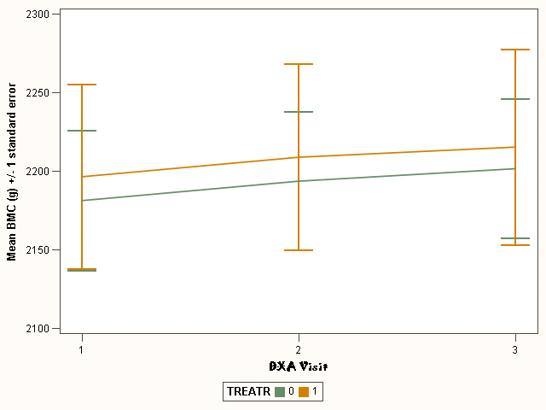
Note that we can now notice a slight increase in BMC over time in both groups (this will become important later). There is actually a significant effect for time here…

- We also have a continuous variable calc1, calcium at baseline; chop this into tertiles, so we can plot by calcium tertile. I’m going to use code to do this:

proc sort data=long; by calc1; run;
Asks for tertiles.
proc rank data=long out=ranks groups=3;
var calc1;
ranks calcranks;
where calc1 ne .;
Dataset work.ranks will contain a variable calc1 that is ranks from 0-2.
label calc1='tertile calcium';
run;

If you don’t name a new variable to store the rank values, SAS will write over the old variable.

Then create a multiple line plot for this variable :
calcranks
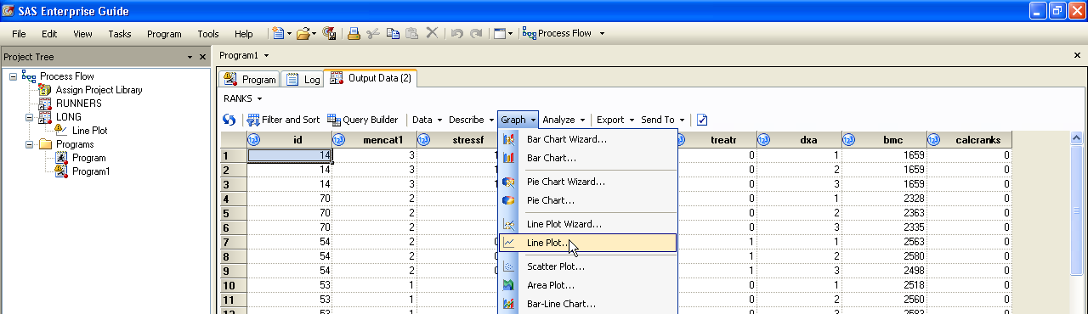
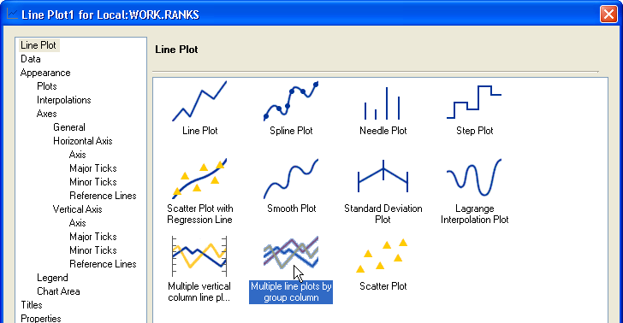

Select dxa as the vertical variable and bmc as the horizontal variable, and choose the calcranks for the group variable. Then Click Edit.
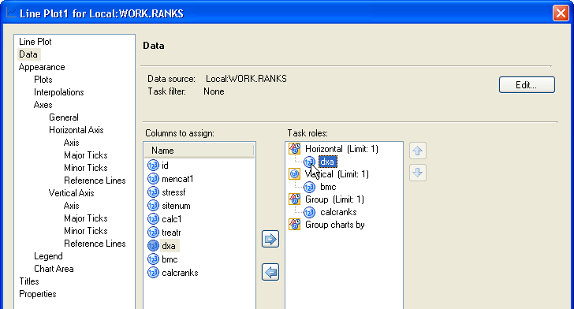

Using the Edit feature, make sure we don’t plot a line for missing data:
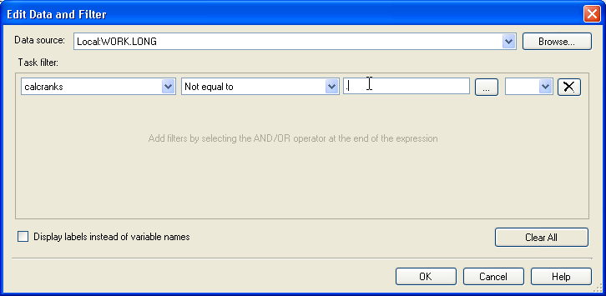

Under Interpolations, choose 1 standard error of the mean error bars and connect the means:
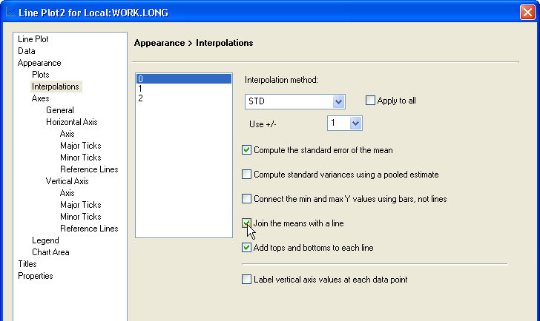

Under Horizontal Axis and Vertical Axis, add axes labels:
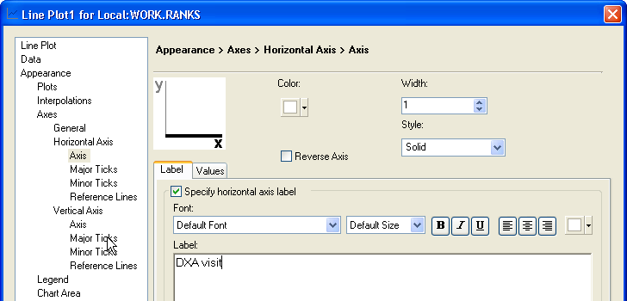
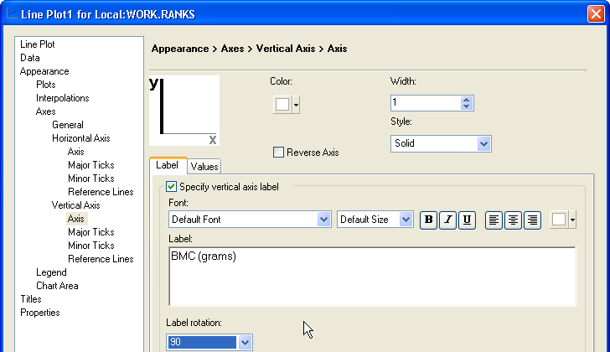

Add a Title to the graph:
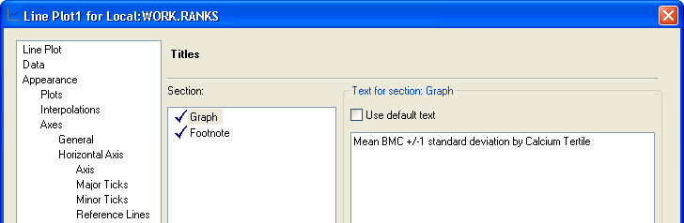

Click Run. And then directly modify code to shrink the vertical axis:

SYMBOL1
INTERPOL=STD1MJT
HEIGHT=10pt
VALUE=NONE
LINE=1
WIDTH=2
mode=include
CV = _STYLE_
;
SYMBOL2
INTERPOL=JOIN
HEIGHT=10pt
VALUE=NONE
LINE=1
WIDTH=2
mode=include
CV = _STYLE_
;
SYMBOL3
INTERPOL=JOIN
HEIGHT=10pt
VALUE=NONE
LINE=1
WIDTH=2
mode=include
CV = _STYLE_
;
Axis1
STYLE=1
WIDTH=1
MINOR=NONE
LABEL=( ANGLE=90 "BMC (grams)")
order=2100 to 2350 by 50;
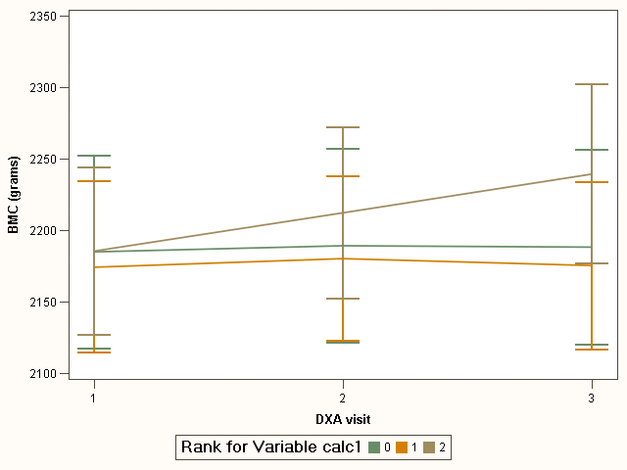
It appears that those in the third quartile of calcium intake at baseline have greater increases in BMC over time, though it’s hard to say if this is going to be statistically significant. So, next we’ll answer that question using repeated-measures ANOVA…

- Strategy 1 to address statistical significance of calcium as a predictor: End point analysis (ANCOVA).

First, create a dataset ranksbroad which ranks calc1 by tertiles. Like above, this is better done with code:

proc sort data=broad; by calc1; run;
This time, I’m just going to write over the variable calc1 with the calcium ranks. So now calc1 is a categorical variable containing the ranks.
proc rank data=broad out=ranksbroad groups=3;
var calc1;
where calc1 ne .;
label calc1='tertile calcium';
run;

Next run ANCOVA on the output dataset, ranksbroad. In EG this can be found under Analyze > ANOVA > Linear Models (recall from last week’s lab).

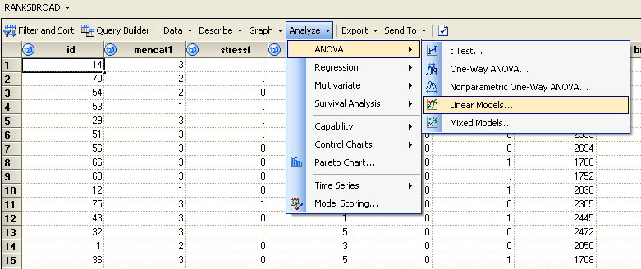

Under Data select bmc3 as the Dependent variable, bmc1 as a Quantitative variable, and calc1 as the Classification variable.
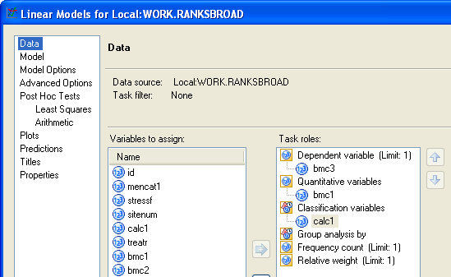
Under Model, choose bmc1 and calc1 for Main effects:
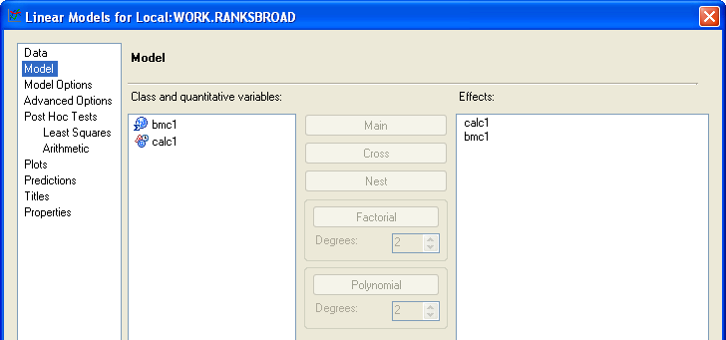

Under Post Hoc Tests, click Add to enable the tests. Enable these for calc1 by selecting True. Select Default for Show p-values, Tukey for the Adjustment method, and then click Run.
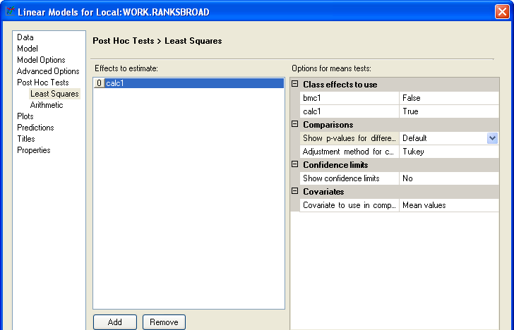

Scroll down to the output:
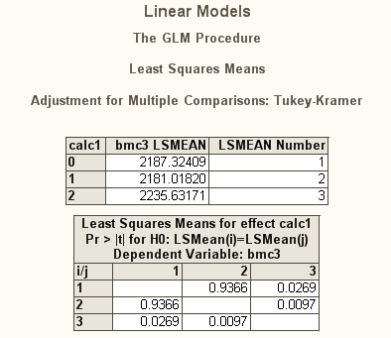
Highest tertile of calcium intake looks different from the lower tertiles at the end of the study, even after adjusting for baseline differences.

FYI, corresponding SAS code:
proc glm data=ranksbroad;
class calc1;
model bmc3= bmc1 calc1 ;
lsmeans calc1 /pdiff adjust=tukey;
run;

- Ignoring calcium for the moment, let’s just explore whether there are significant changes in BMC over time (time effect only). Start by running the naïve (incorrect!) ANOVA analysis—forgetting to take into account the correlation within subjects.

FYI, this is what happens to the means over time in the group as a whole (I’ve exaggerated the graph here so you can see the increase). Code to make this graph (mean plot only with no standard error bars) is also shown below (FYI).
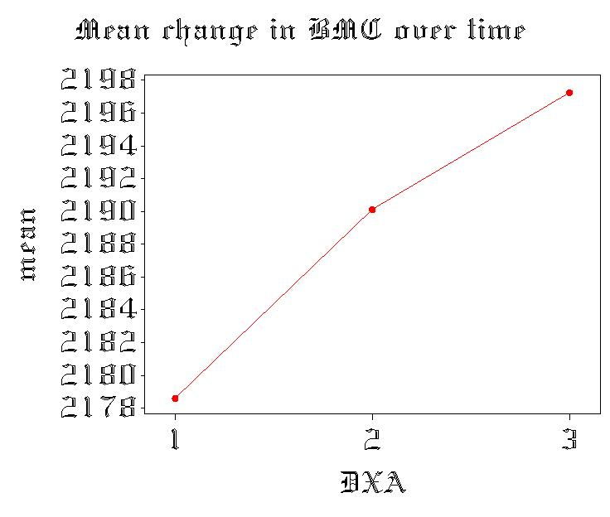
proc sort data=long; by dxa; run;

proc means data=long noprint nway;
var bmc;
by dxa;
output out=mymeans mean=mean ;
run;

goptions reset=all ftext=oldeng htext=3;
title "Mean change in BMC over time";
axis1 label=('DXA') offset=(1 cm) minor=none;
axis2 label=(angle=90) minor=none;
proc gplot data=mymeans;
plot mean*dxa /haxis=axis1 vaxis=axis2 nolegend;
symbol1 v=dot i=join c=red r=1 line=1;
run; quit;

In EG click on the LONG dataset. Go to Analyze > ANOVA > One-Way ANOVA.
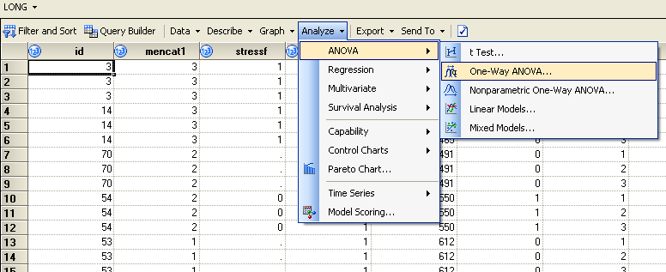

Under Data select bmc as the Dependent and dxa as the Independent variables.
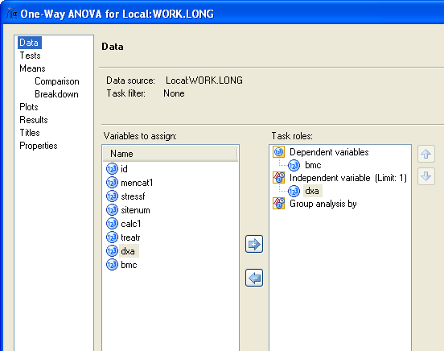

Under Means > Breakdown, check Mean to get the mean calc1 for each level of dxa
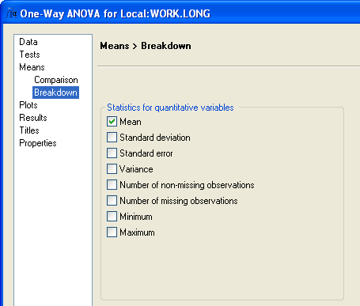

Click Run.

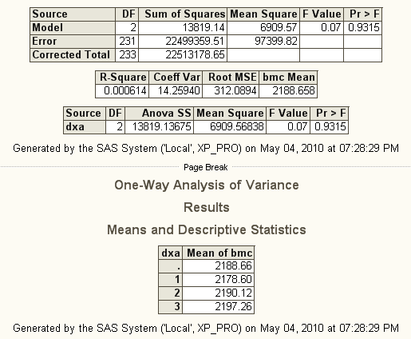
No evidence of change over time! P=.93.
Note the enormous amount of unexplained variability!

In SAS code:

proc anova data=long;
class dxa;
model bmc = dxa ;
means dxa;
run;

- Now, run repeated-measures ANOVA, accounting for the variability that’s due to subject.
The only way to do repeated-measures ANOVA in SAS EG is to do it in PROC mixed (ANOVA→Mixed models). This gives slightly different results, however, because it’s using a slightly different method to estimate effects (maximum likelihood estimation rather than least-squares). Unfortunately, the point-and-click version of PROC GLM is not set-up to do repeated-measures ANOVA. So, we’re going to code this part.

proc glm data=broad;
model bmc1-bmc3= / nouni;
repeated time;
run; quit;

- Scroll through the output to find the folder “WITHIN” under repeated measures (univariate). Now the change looks significant, even after adjusting for violations of sphericity!

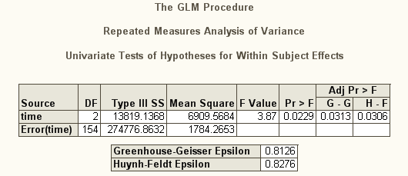
Sphericity is not too badly violated….
Time effect is significant once you account for the high correlation within subjects!
Notice the ENORMOUS reduction in unexplained variability; but variability due to time (SSB for time) does not change.

- Scroll through to find the MANOVA output; gives generally same conclusion as univariate repeated measures: there is a significant increase over time.
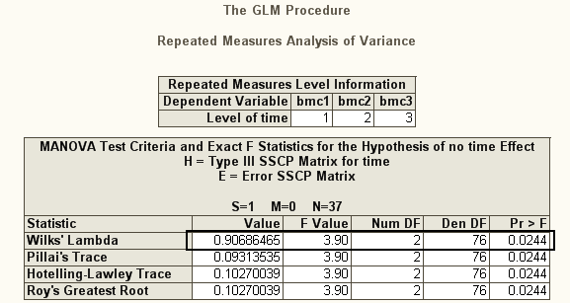

- We should also check the variance/covariance matrix for bmc1, bmc2, and bmc3 to assess whether compound symmetry is met (recall: compound symmetry is an assumption of univariate, but not multivariate repeated measures ANOVA).
In EG, go to the BROAD dataset and click on Analyze > Multivariate > Correlations:

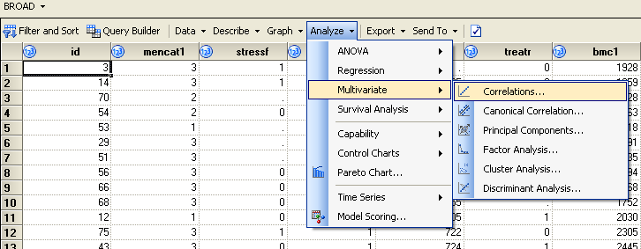

Under Data, select bmc1-3 as your Analysis variables.

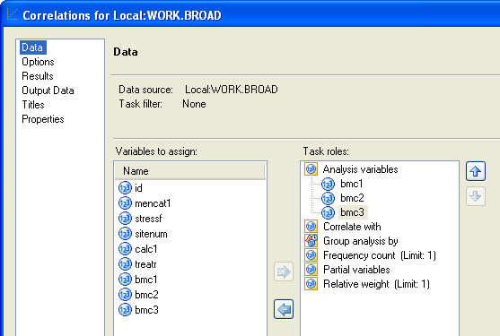

Under Options, select Pearson correlation and the option to obtain Covariances.
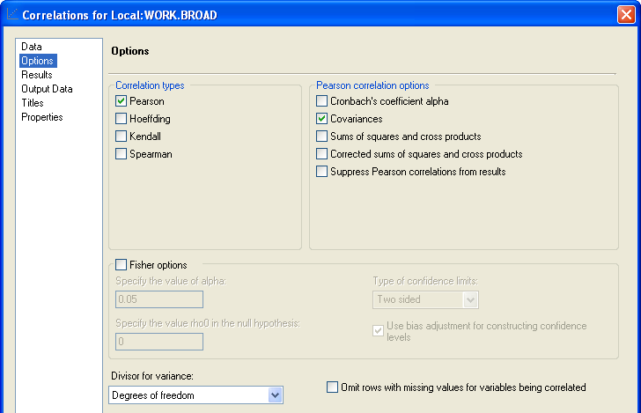

Click Run.

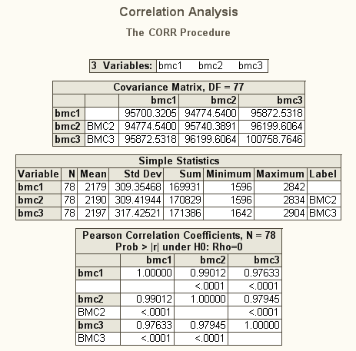
-Variance looks just slightly higher for bmc3.
-The three covariances/correlations look similar with the highest correlation between bmc1 and bmc2.
-Looks like compound symmetry is relatively well satisfied.

-Under compound symmetry, we estimate 1 variance and 1 covariance (cost is only 2 degrees of freedom).
-MANOVA allows a completely “unstructured” variance/covariance matrix, where all 6 variances and covariances are estimated (costs 6 degrees of freedom).
-We’ll discuss alternatives to compound symmetry and unstructured next week.

FYI, corresponding SAS code:
proc corr data=broad cov;
var bmc1 bmc2 bmc3;
run;

19. Now, run repeated-measures ANOVA with a predictor: calcium tertile.

FYI, corresponding graph (without the standard error bars) and SAS code to make the graph:
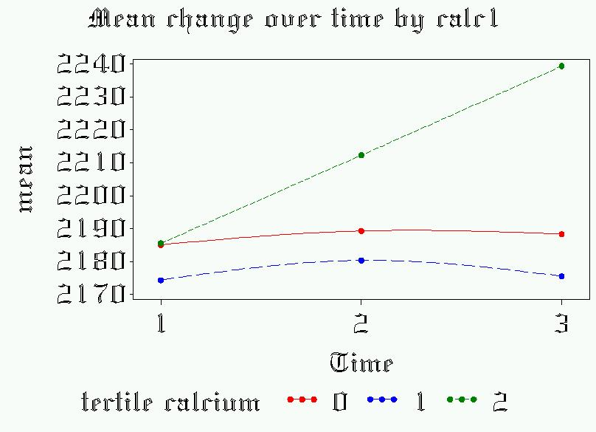
proc sort data=ranks; by calcranks dxa; run;
proc means data=ranks noprint nway;
var bmc;
by calcranks dxa;
output out=mymeans mean=mean ;
run;
goptions reset=all ftext=oldeng htext=3;
title "Mean change in BMC over time by calcium tertile";
axis1 label=('DXA') offset=(1 cm) minor=none ;
axis2 label=(angle=90) minor=none;
proc gplot data=mymeans;
plot mean*dxa=calcranks /haxis=axis1 vaxis=axis2;
symbol1 v=dot i=join c=red r=1 line=1;
symbol2 v=dot i=join c=blue line=2;
symbol3 v=dot i=join c=green line=3;
run; quit;

Again, we’re going to use SAS code to run repeated-measures ANOVA in PROC GLM:
proc glm data=ranksbroad;
class calc1;
model bmc1-bmc3= calc1/ nouni;
repeated time;
run; quit;

MANOVA output:

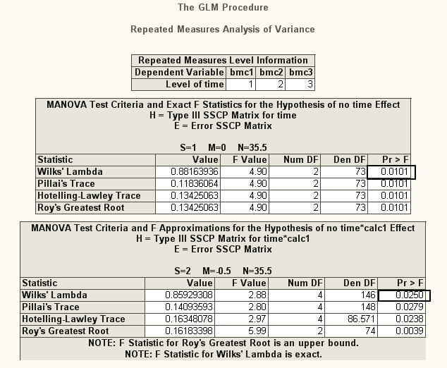
Changes over time are significant.
time*calcium is significant, indicating a difference between at least two of the calcium groups in their response profile over time, as we saw in the graph.
Changes over time differ between calcium groups.

Univariate rANOVA output:

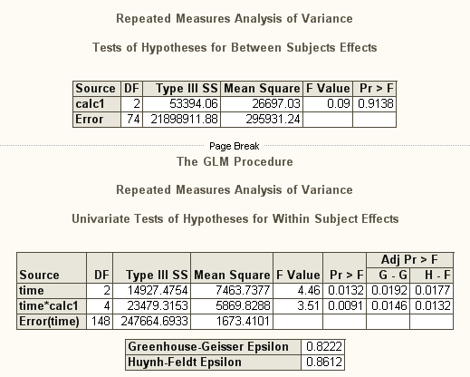
DXA*calcium is significant, Time is significant. (same results as MANOVA)
No overall differences between calcium groups.

- Contrast these results with repeated-measures ANOVA comparing treatment group. Here, the graph indicates about a 20-gram BMC difference overall between the two groups and about a 20-gram increase over time, but not a difference in responses over time by group. Additionally, try out the polynomial option (recall, this assesses shape of the response over time: linear or quadratic are our only choices). Looks fairly linear.
proc sort data=long; by treatr dxa; run;
proc means data=long noprint nway;
var bmc;
by treatr dxa;
output out=mymeans mean=mean ;
where treatr ne .;
run;
goptions reset=all ftext=oldeng htext=3;
title "Mean change in BMC over time by treatment randomization";
axis1 label=('DXA') offset=(1 cm) minor=none ;
axis2 label=(angle=90) minor=none;
proc gplot data=mymeans;
plot mean*dxa=treatr /haxis=axis1 vaxis=axis2 nolegend;
symbol1 v=dot i=join c=red r=1 line=1;
symbol2 v=dot i=join c=blue line=2;
run; quit;

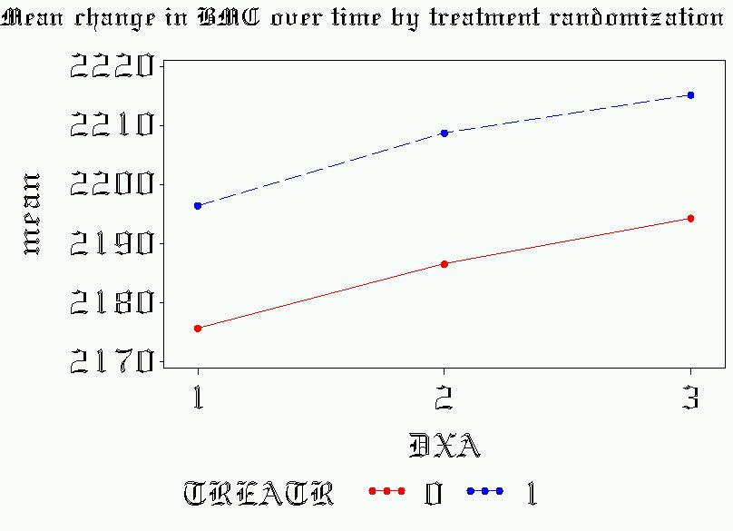

proc glm data=broad;
class treatr;
model bmc1-bmc3= treatr;
repeated time 2 polynomial / summary;
run; quit;

MANOVA output:
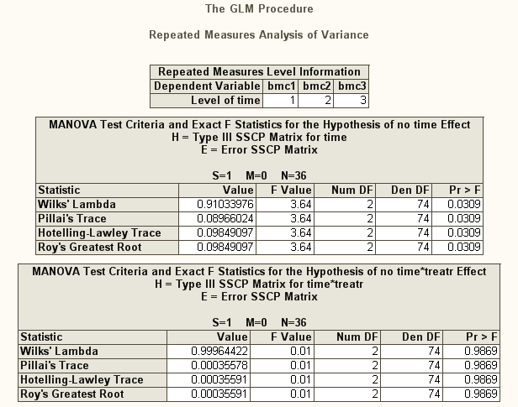
Increase over time is statistically significant (as before).
But response profile does not differ by group.

Univariate rANOVA output:
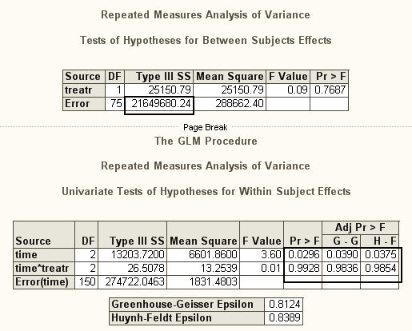
Response profiles over time are not different between groups.
No significant difference overall between groups.
Increase over time is statistically significant.
Same conclusions as MANOVA!

Looking at shape of the response profile:

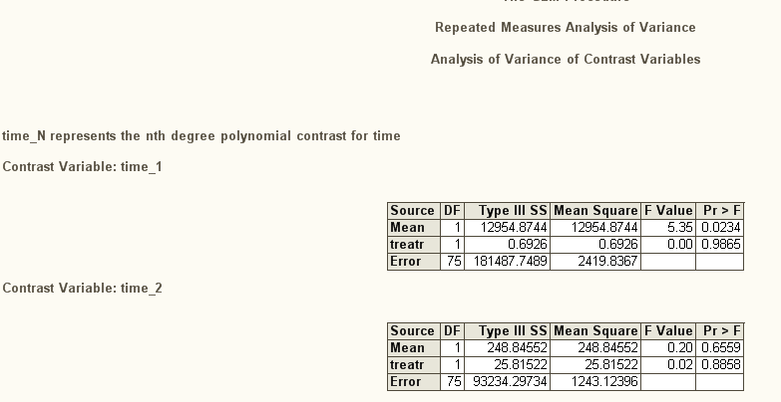
Linear is clearly the better choice for shape.

APPENDIX, LAB 6

Options for fonts in PROC GPLOT:
Syntax examples—to reset the default font for subsequent graphics:
(ftext=font type, htext=font size):
goptions reset=all ftext=titalic htext=3;

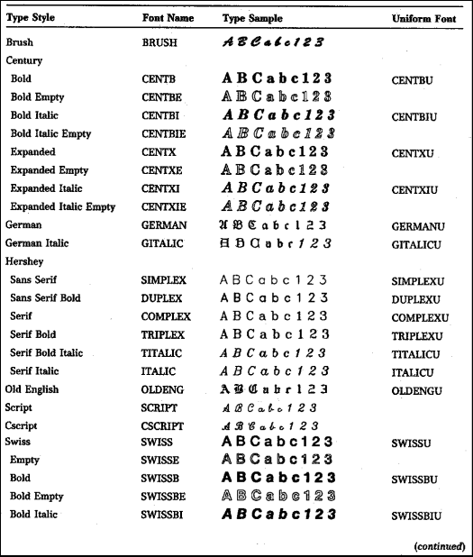

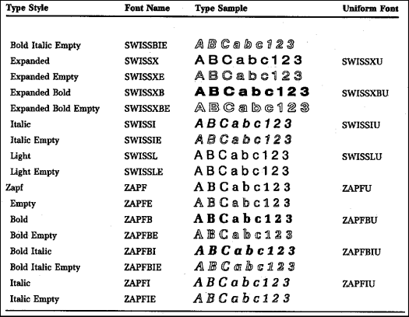

If you want reinforcement on repeated measures ANOVA, try this website (online seminar from UCLA covering many of the same topics as I did on Monday):
http://www.ats.ucla.edu/stat/sas/seminars/sas_repeatedmeasures/default.htm

