Lab Two: Mantel-Haenszel test and Mantel-Haenszel OR/RR, introduction to McNemar’s Test

Lab Objectives
After today’s lab you should be able to:

- Distinguish between numeric and character variables in SAS.
- Use PROC FREQ to generate stratified 2x2 tables.
- Use PROC FREQ to generate Mantel-Haenszel statistics and the Mantel-Haenszel summary OR/RR and Breslow-Day test of Homogeneity.
- Interpret Mantel-Haenszel results.
- Practice using the RESULTS browser (left hand side of screen) to scroll through output.
- Input paired data directly into SAS.
- Use PROC FREQ to generate McNemar’s statistic for paired or matched data.
- Change grouped data into a dataset that contains 1 observation for each individual.
- Use a do-loop.
- Use an if-then-do loop.
- Use nested loops.
- Use the output statement to add observations to a dataset that you are modifying.
- See the connection between CMH and McNemar’s tests.

SAS PROCs SAS EG equivalent
PROC FREQ Describe→Table Analysis
PROC LOGISTIC Analyze→Regresssion→Logistic regression

LAB EXERCISE STEPS:

Follow along with the computer in front…
- Double-click on the SAS EG icon to open SAS EG.
- Select New Project.
- On the menus, select File>New>Data

- Create a new dataset admissions in the WORK library.

In Name, type admissions (SAS is cap-insensitive). Then click on the work library (filing cabinet drawers represent libraries).
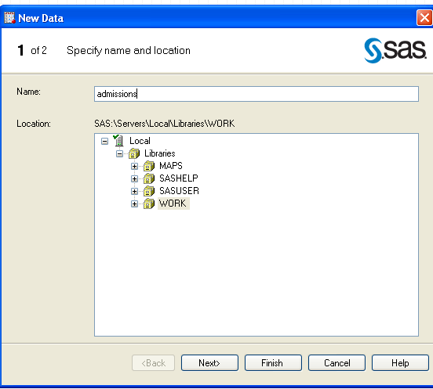
SAS distinguishes between numeric variables (which can be manipulated arithmetically) and character variables. Here, the first variable is character; the rest are numeric.
.

Then Click Next>

Click on the first variable (A). Name the variable “program” and then as save it as character variable (default).

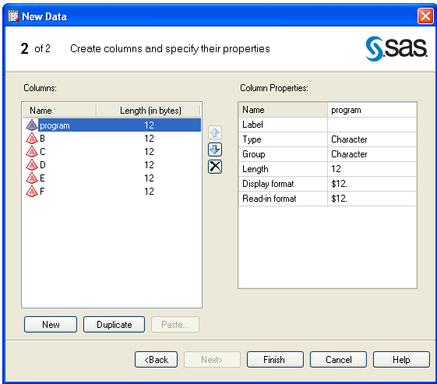

Call the subsequent variables: IsFemale, Denied, Count and save them as numeric variables. Click on Finish to look at your data.
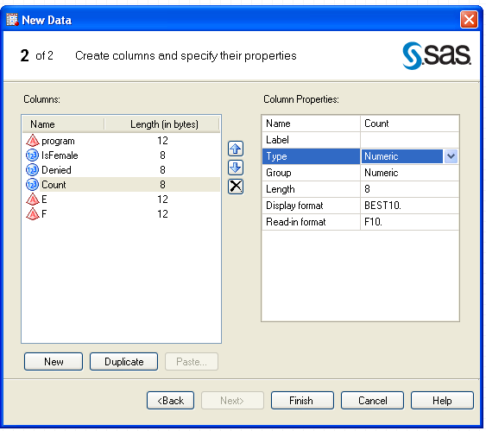

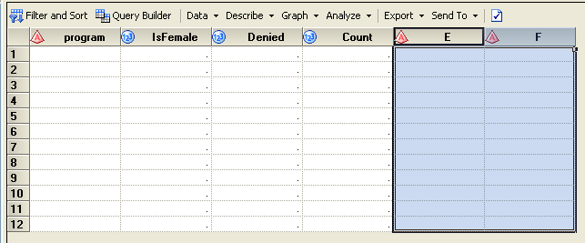
Your data table will behave just as an excel table. First select with the last two columns and delete them with the key Delete (just as if it would be an excel table!)

Go to the class website: www.stanford.edu/~kcobb/courses/hrp261 --> Lab 2 Data
Highlight the following data with your mouse; copy with ctrl C:
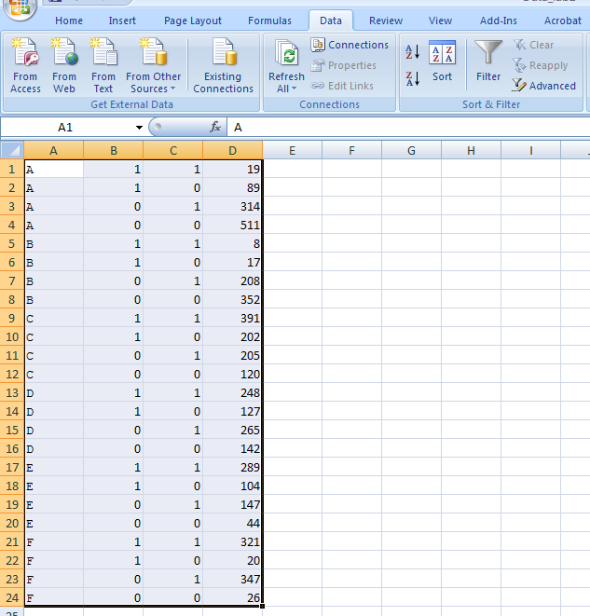

Paste it with Ctrl-V. Note that the numeric variables are aligned toward the right, but the character variable is aligned towards the left. 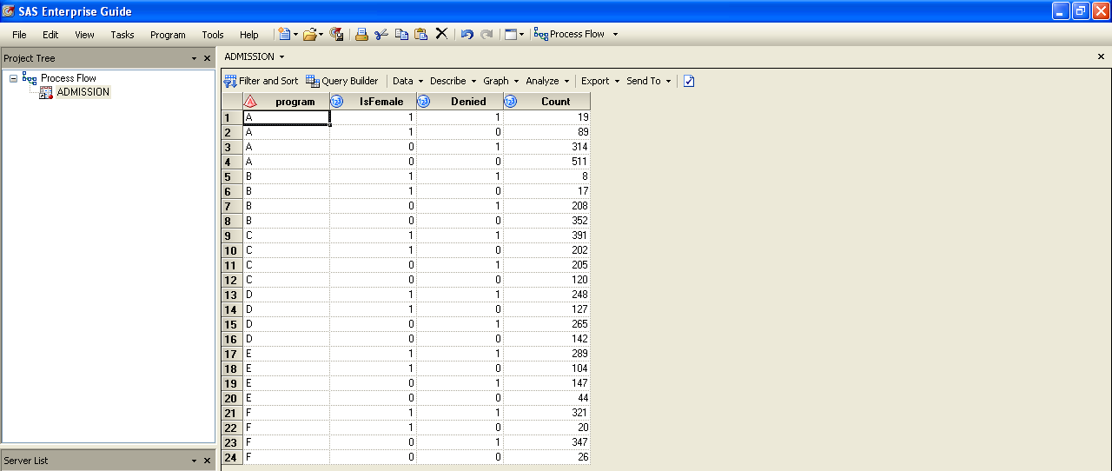

- It is much easier to create the dataset by programming. The code to create the data set in SAS is the following:
data admissions;
input program $ IsFemale Denied Count;
datalines;
A 1 1 19
A 1 0 89
A 0 1 314
A 0 0 511
B 1 1 8
B 1 0 17
B 0 1 208
B 0 0 352
C 1 1 391
Type a dollar sign after the variable name to make the variable a character variable. Numeric variables are the default.

C 1 0 202
C 0 1 205
C 0 0 120
D 1 1 248
D 1 0 127
D 0 1 265
D 0 0 142
E 1 1 289
E 1 0 104
E 0 1 147
E 0 0 44
F 1 1 321
F 1 0 20
F 0 1 347
F 0 0 26
;
run;

- Now we will test for association between gender and admissions. First we have to create a 2x2 table. Click on Describe>Table Analysis
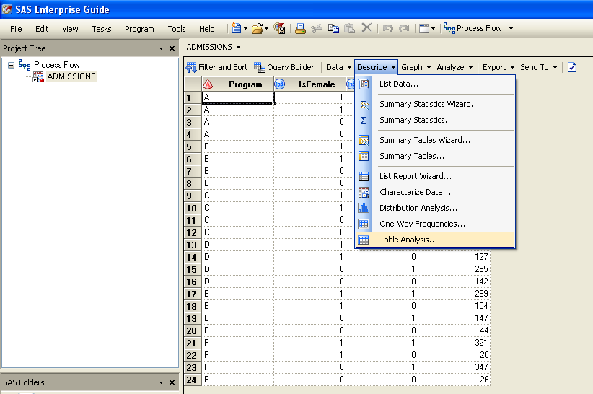

In the Data Screen drag “IsFemale” and “Denied” to make them the Table variables and “count” to make it the frequency (weighting) variable.
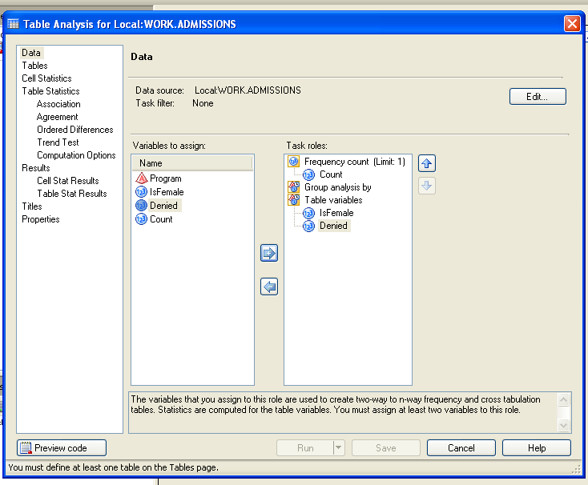

Click on Tables in the left-hand menu. In the Tables screen, drag and drop IsFemale to make it the row variable, and drag Denied to make it the column variable.
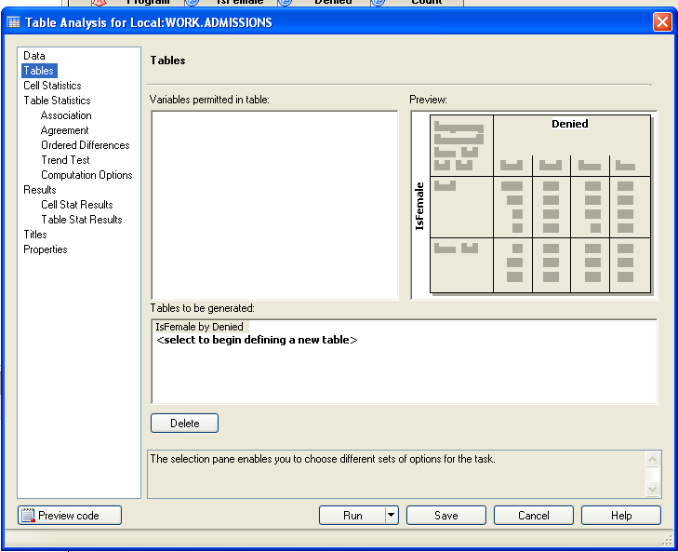

In the Cell Statistics menu check the boxes Cell Frequencies and Expected Cell Frequency (uncheck Cell percentages if it is checked)
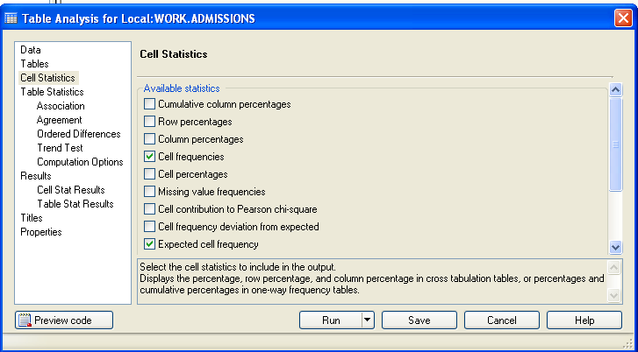

Click on Table Statistics>Association in the left-hand menu. In this screen check the boxes labeled Chi-Square tests, Fisher’s exact test and Measures.
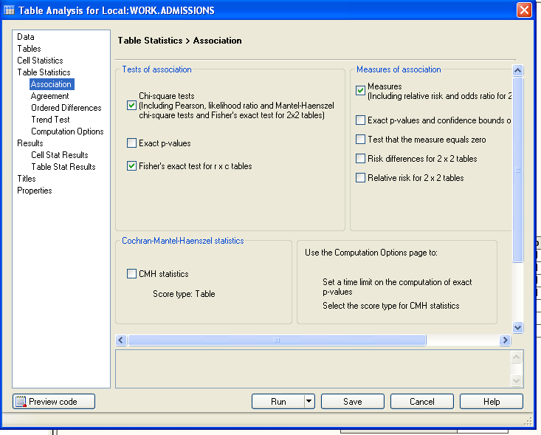

Click on Preview Code, which allows you to see the code that SAS has automatically generated.
The relevant code that generates the table and the statistics is the PROC FREQ (the frequency procedure) code. Some of the automatically generated code is not essential. Here is the code I would use to repeat the analyses that we have just done with point-and-click:
If you care to see expected counts in the table
/**IS gender related to denial of graduate admissions at Berkeley?**/
proc freq data=admissions order=data;
tables isfemale*denied /chisq nocol nopercent norow measures expected ;
Suppresses annoying row, column, and overall percents…
Ask for chi-square test
weight count;
run;

Asks for crude OR and RR’s

When doing the homeworks, you may decide that it is faster to use coding rather than point-and-click, so save the code for future reference!
If you are familiar with the code, you can also directly modify the automatically generated code, which can save you repeated pointing and clicking. I will show an example in class.

Review the code (as a class). Then close the code and click Run to run the code.

OUTPUT:

Calculation of Chi-Square statistic
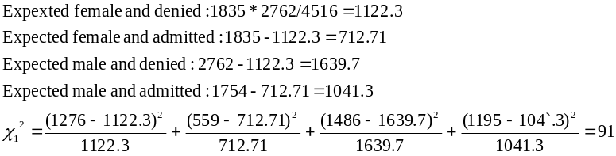

Table of IsFamale by Denied
 |  | Denied |  | Total
 |  | 1 | 0 | Total
IsFamale |  | 1276 | 559 | 1835
1 | Frequency | 1276 | 559 | 1835
1 | Expected | 1122.3 | 712.71
0 | Frequency | 1486 | 1195 | 2681
0 | Expected | 1639.7 | 1041.3
Total | Frequency | 2762 | 1754 | 4516

Statistic | DF | Value | Prob
Chi-Square | 1 | 91.2997 | <.0001
Likelihood Ratio Chi-Square  Strong evidence of an association between gender and admissions (p<.0001) | 1 | 92.5105 | <.0001
Continuity Adj. Chi-Square | 1 | 90.7067 | <.0001
Mantel-Haenszel Chi-Square | 1 | 91.2795 | <.0001
Phi Coefficient |  | 0.1422
Contingency Coefficient |  | 0.1408
Cramer's V |  | 0.1422

Fisher’s Exact test is automatically generated for 2x2 tables; use when expected cell sizes < 5. Use the option “exact” or “Fisher” to ask for Fisher’s exact test for contingency tables larger than 2x2.

Fisher's Exact Test
Cell (1,1) Frequency (F) | 1276
Left-sided Pr <= F | 1.0000
Right-sided Pr >= F  It is not necessary to use Fisher’s exact test here. If you were using Fisher’s exact test, you would report the two-sided probability. | 4.579E-22
Table Probability (P) | 3.846E-22
Two-sided Pr <= P | 8.408E-22

Estimates of the Relative Risk (Row1/Row2)
Type of Study  Crude OR  Female vs. male: 1.84  Crude RR (females vs. males) =1.25 (1.20,1.31)  Conclusion: Women 25% more likely to be denied admission (and we’re 95% certain that the true increase in risk is somewhere between 20% and 31%). | Value | 95% Confidence Limits
Case-Control (Odds Ratio) | 1.8356 | 1.6196 | 2.0805
Cohort (Col1 Risk) | 1.2546 | 1.1988 | 1.3130
Cohort (Col2 Risk) | 0.6834 | 0.6303 | 0.7411
This is the risk of being admitted, rather than the risk of being denied (reduced 32% in females).
7. Could Program be a confounder of the relationship between gender and denial of admissions?
Is program related to gender?
Is program related to admissions rates?
We can repeat the Chi-square test for the variables IsFemale and Program

Describe>Table
Select IsFemale and Progam as Table variables. Select Count as Frequency count
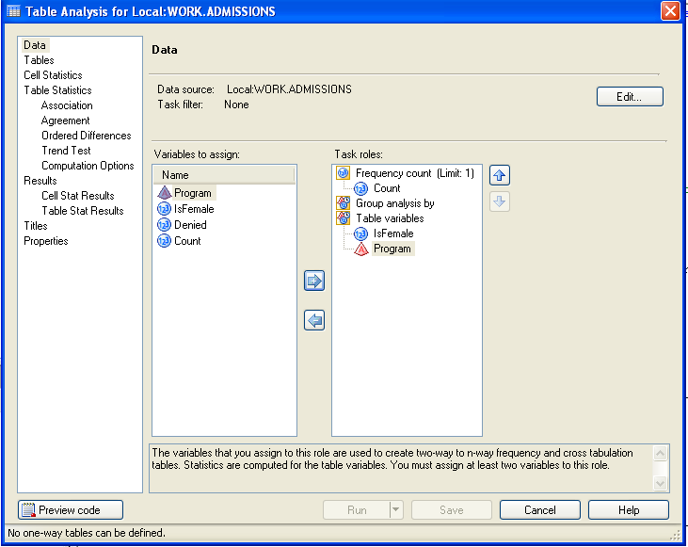

Go to Tables in the left hand side and Drag IsFemale and Program
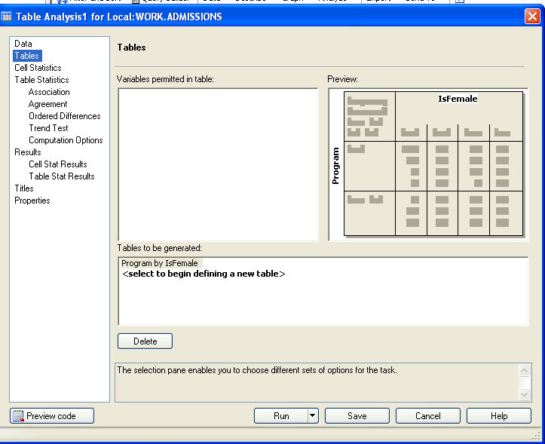

On the left hand menu select Association. Then click on the boxes Chi-square tests and Measures
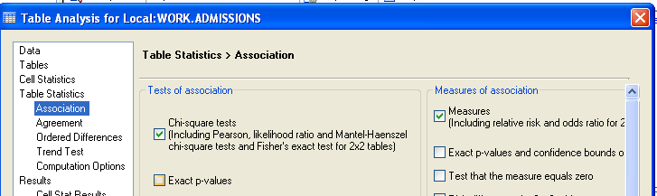

Then Click Run.

FYI, the corresponding codes for this analysis is:

proc freq data=admissions order=data;
tables program*isfemale /chisq nocol nopercent norow measures ;
weight count;
run;

OUTPUT:

Table of program by IsFamale
 |  | IsFamale |  | Total
 |  | 1 | 0 | Total
program |  | 108 | 825 | 933  Programs A and B are heavily male; C and E are more female-dominated.
A | Frequency | 108 | 825
B | Frequency | 25 | 560 | 585
C | Frequency | 593 | 325 | 918
D | Frequency | 375 | 407 | 782
E | Frequency | 393 | 191 | 584
F | Frequency | 341 | 373 | 714
Total | Frequency | 1835 | 2681 | 4516

Statistic | DF | Value | Prob
Chi-Square | 5 | 1070.2064 | <.0001  Program and gender are strongly related.
Likelihood Ratio Chi-Square | 5 | 1223.1456 | <.0001
Mantel-Haenszel Chi-Square | 1 | 508.8900 | <.0001
Phi Coefficient |  | 0.4868
Contingency Coefficient |  | 0.4377
Cramer's V |  | 0.4868

8. Repeat the analysis for Program and Denied using code. New→Program:.

proc freq data=admissions order=data;
tables program*denied /chisq nocol nopercent norow measures ;
weight count;
run;

Table of program by Denied
 |  | Denied |  | Total
 |  | 1 | 0 | Total
program |  | 333 | 600 | 933  It’s really tough to get into program F, and not too hard to get into A or B.
A | Frequency | 333 | 600
B | Frequency | 216 | 369 | 585
C | Frequency | 596 | 322 | 918
D | Frequency | 513 | 269 | 782
E | Frequency | 436 | 148 | 584
F | Frequency | 668 | 46 | 714
Total | Frequency | 2762 | 1754 | 4516

Statistic | DF | Value | Prob
Chi-Square | 5 | 771.6742 | <.0001
Likelihood Ratio Chi-Square | 5 | 848.5218 | <.0001
Mantel-Haenszel Chi-Square | 1 | 717.1111 | <.0001
Phi Coefficient |  | 0.4134
Contingency Coefficient |  | 0.3820
Cramer's V |  | 0.4134

So, Program is strongly related to both gender and admissions
9. Now, stratify on Program…
Click on the Admissions dataset. Click on Describe>Tables. Then Select IsFemale, Denied and Program as Table Variables and Count as Frequency count.
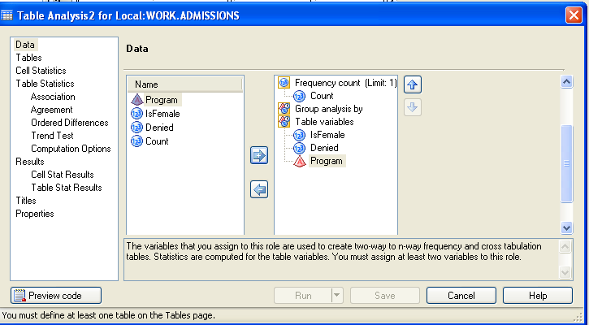

On the left hand menu select Cell Statistics. Then check Cell Frequencies and Expected cell Frequency

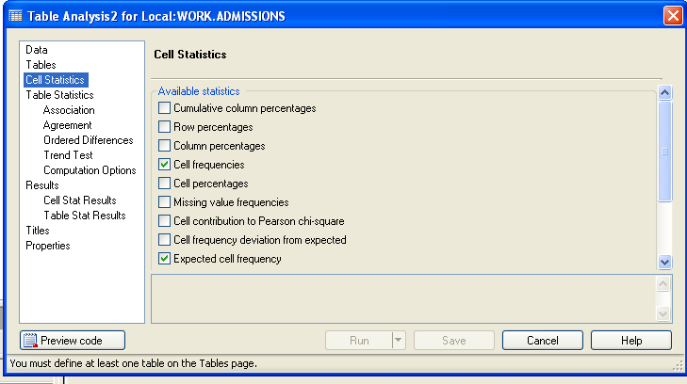

Drag all the variables in the Tables Menu on the left-hand side, as pictured below (hint: drag denied in first, then isfemale, then program):
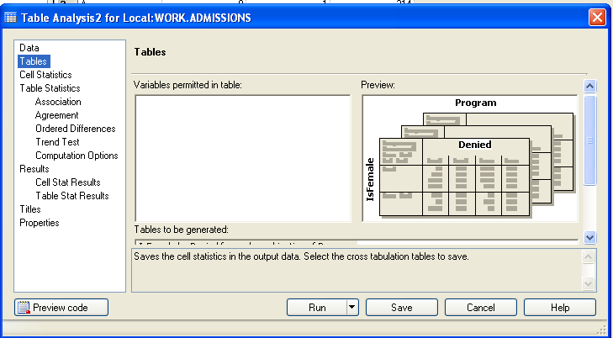

On the left hand menu select Association. Then check the Chi-Square tests and measures boxes.

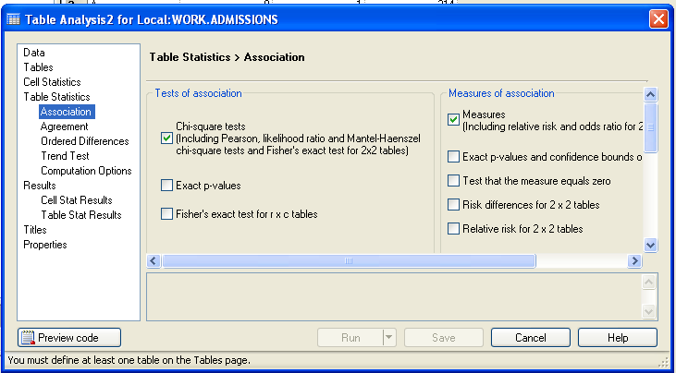
Then Click Run.

FYI, the corresponding code would be:

/**IS gender related to denial of graduate admissions at Berkeley after adjusting for program?**/
proc freq data=admissions order=data;
tables program*isfemale*denied /cmh nocol nopercent norow measures;
weight count;
run;

Asks for (Cochran) Mantel-Haenszel chi-square test and summary odds and risk ratios.
Asks for stratum-specific measures of association.
Strata variable*Row variable* Column Variable
OUTPUT:
Table 1 of IsFamale by Denied
Controlling for program=A
 |  | Denied |  | Total
 |  | 0 | 1 | Total
IsFamale |  | 511 | 314 | 825
0 | Frequency | 511 | 314 | 825
0 | Col Pct | 85.17 | 94.29
1 | Frequency | 89 | 19 | 108
1 | Col Pct | 14.83 | 5.71
Total | Frequency | 600 | 333 | 933

Estimates of the Relative Risk (Row1/Row2)
Type of Study | Value | 95% Confidence Limits
Case-Control (Odds Ratio) | 0.3474 | 0.2076 | 0.5814
Cohort (Col1 Risk) | 0.7516 | 0.6786 | 0.8325
Cohort (Col2 Risk) | 2.1634 | 1.4252 | 3.2840

Stratum-specific RR for Program A.

Table 2 of IsFamale by Denied
Controlling for program=B
 |  | Denied |  | Total
 |  | 0 | 1 | Total
IsFamale |  | 352 | 208 | 560
0 | Frequency | 352 | 208 | 560
0 | Col Pct | 95.39 | 96.30
1 | Frequency | 17 | 8 | 25
1 | Col Pct | 4.61 | 3.70
Total | Frequency | 369 | 216 | 585

Estimates of the Relative Risk (Row1/Row2)
Type of Study | Value | 95% Confidence Limits
Case-Control (Odds Ratio) | 0.7964 | 0.3378 | 1.8775
Cohort (Col1 Risk) | 0.9244 | 0.7012 | 1.2186
Cohort (Col2 Risk) | 1.1607 | 0.6489 | 2.0762

Controlling for program=C

Table 3 of IsFamale by Denied
Controlling for program=C
 |  | Denied |  | Total
 |  | 0 | 1 | Total
IsFamale |  | 120 | 205 | 325
0 | Frequency | 120 | 205 | 325
0 | Col Pct | 37.27 | 34.40
1 | Frequency | 202 | 391 | 593
1 | Col Pct | 62.73 | 65.60
Total | Frequency | 322 | 596 | 918

Estimates of the Relative Risk (Row1/Row2)
Type of Study | Value | 95% Confidence Limits
Case-Control (Odds Ratio) | 1.1331 | 0.8545 | 1.5024
Cohort (Col1 Risk) | 1.0839 | 0.9045 | 1.2989
Cohort (Col2 Risk) | 0.9566 | 0.8645 | 1.0586
ETC...
Non-significant Cochran-Mantel Haenzel test tells us that after controlling for program, there’s no evidence of an association between gender and admissions.

Cochran-Mantel-Haenszel Statistics (Based on Table Scores)
Statistic | Alternative Hypothesis | DF | Value | Prob
1 | Nonzero Correlation | 1 | 1.4972 | 0.2211
2 | Row Mean Scores Differ | 1 | 1.4972 | 0.2211
3 | General Association | 1 | 1.4972 | 0.2211

Estimates of the Common Relative Risk (Row1/Row2)
Adjusted RR=.95 (.87-1.03), suggesting that after controlling for program, women and men have about the same overall admissions rate.
Type of Study | Method | Value | 95% Confidence Limits
Case-Control | Mantel-Haenszel | 0.9049 | 0.7717 | 1.0612
(Odds Ratio) | Logit | 0.9284 | 0.7894 | 1.0918
Cohort | Mantel-Haenszel | 0.9451 | 0.8660 | 1.0314
(Col1 Risk) | Logit | 0.8652 | 0.8030 | 0.9322
Cohort | Mantel-Haenszel | 1.0275 | 0.9830 | 1.0739
(Col2 Risk) | Logit | 0.9958 | 0.9645 | 1.0280
Breslow-Day test actually rejects here because, unlike the other programs, women actually have an advantage in program A. So program A has a different relationship than the others, and we do not meet the assumption of homogeneity.

Breslow-Day Test for
Homogeneity of the Odds Ratios
Chi-Square | 18.5989
DF | 5
Pr > ChiSq | 0.0023

10. Just to show the parallels (and as a preview of what’s to come), let’s also run a multivariate regression (logistic regression) with and without adjustment for confounding by program to see what effect that has on the point estimate for gender. Don’t worry too much about the coding right now—we’ll get back to this later in the term.

In the Input Data window select Analyze>>Regression>>Logistic Regression

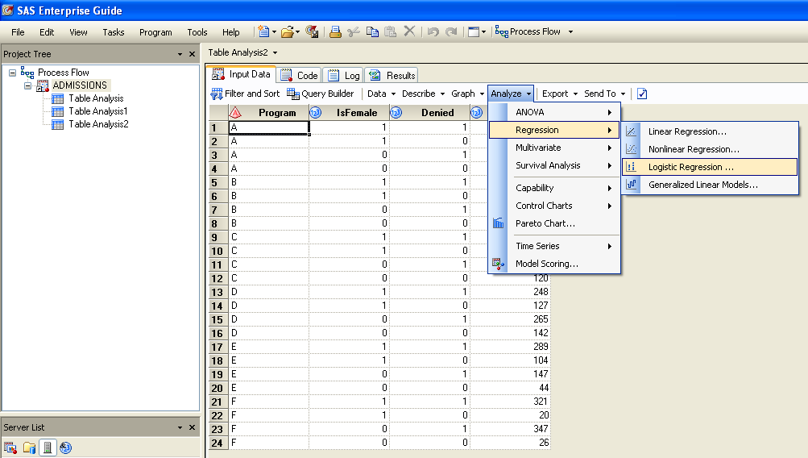

On the left menu select Data. Then Selcet Denied as dependent variable, IsFemale as quantitative variable and Count as Relative weight
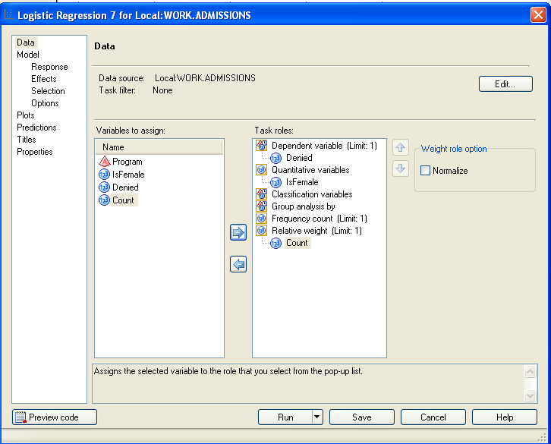

On the left hand menu select Response. Then select Fit model to level 1. This will model the odds of being denied (Denied=1), rather than the odds of being accepted.

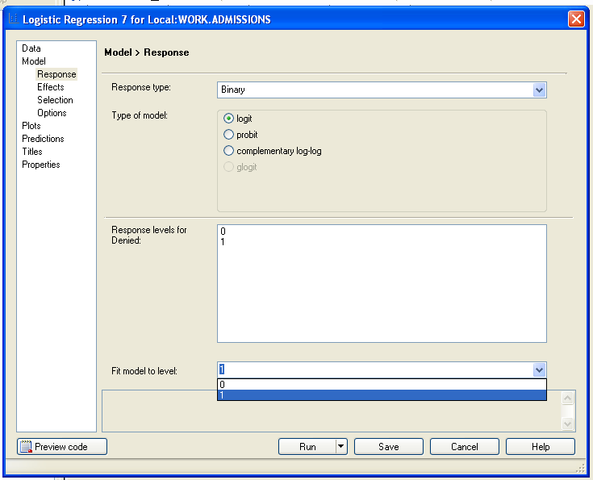

On the Left hand Menu select Effects. Then click on IsFemale and Select Main. Finally click on Run.
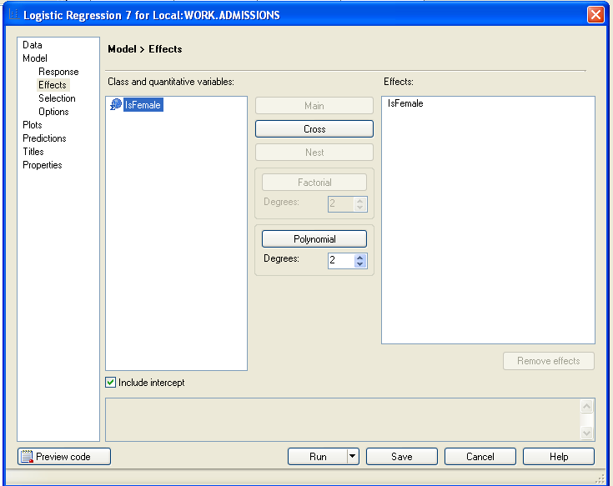

This is a simple logistic model with gender as the only predictor. Corresponding SAS code:
This is a regression model where gender is the predictor and denial of admission is the outcome.
proc logistic data=admissions;
model denied (event="1") = isfemale;
weight count;
run;
Remember, we have grouped data, so we can’t forget to weight by our count variable!

Here is the parameter estimate (beta coefficient) for gender:
The LOGISTIC Procedure

Analysis of Maximum Likelihood Estimates

Standard Wald
Parameter DF Estimate Error Chi-Square Pr > ChiSq

Intercept 1 0.2179 0.0389 31.4605 <.0001
IsFemale 1 0.6073 0.0639 90.3529 <.0001
There is a significant relationship between gender and admissions; the magnitude of the effect is reflected in a beta coefficient of +.60.

To adjust for confounding by program, simply add program to the model.
We can do this by directly modifying the automatically generated code. Select the Program tab. Scroll to find the PROC LOGISTIC code:

- In PROC LOGISTIC, replace the temporary dataset that SAS creates (using PROC SQL) with the original dataset. (The temporary dataset will not contain the variable program).
PROC LOGISTIC data=admissions;

- Add Program to the model after isFemale (separated only by spaces).

PROC LOGISTIC…
MODEL Denied (Event = '1')= isfemale program/

Click Run to run the code:

- Say yes when it asks you if you want to modify the code and yes when it asks you if you want to replace the code.

Now we have a logistic model with two predictors, gender and program. The resulting beta coefficients are each “adjusted for” each other:

Analysis of Maximum Likelihood Estimates

Standard Wald
Parameter DF Estimate Error Chi-Square Pr > ChiSq

Intercept 1 0.6893 0.0513 180.2711 <.0001
IsFemale 1 -0.0990 0.0809 1.4986 0.2209

To evaluate confounding, look at what happens to the beta coefficient for gender.
Adding program to the model removes the effect for gender completely (the beta coefficient for gender is now about 0).

11. We can also check for an interaction (effect modification) between gender and program by adding an interaction term into the model (directly modify the code again):

proc logistic data=admissions;
class program;
model denied (event="1") = isfemale program isfemale*program;
weight count;
Interaction term is the product of the two variables.
run;

Analysis of Maximum Likelihood Estimates

Standard Wald
Parameter DF Estimate Error Chi-Square Pr > ChiSq

Intercept 1 0.6573 0.0547 144.4267 <.0001
IsFemale 1 -0.1858 0.1107 2.8175 0.0932
program A 1 -1.1443 0.0801 203.9757 <.0001
program B 1 -1.1834 0.0899 173.0928 <.0001
program C 1 -0.1218 0.1086 1.2567 0.2623
program D 1 -0.0334 0.1010 0.1092 0.7410
program E 1 0.5490 0.1506 13.2884 0.0003
IsFemale*program A 1 -0.8714 0.2414 13.0361 0.0003
IsFemale*program B 1 -0.0419 0.3740 0.0126 0.9108
IsFemale*program C 1 0.3107 0.1614 3.7039 0.0543
IsFemale*program D 1 0.2311 0.1655 1.9496 0.1626
IsFemale*program E 1 0.00157 0.2016 0.0001 0.9938
There is a significant interaction between program A and gender.
PartII: McNemar’s Test is used when you have paired or matched data, such as in a matched case-control study. The idea is: you analyze the data by pairs rather than by individuals. Only pairs that are discordant (i.e., cases and controls differ on exposure) provide useful information. Under the null hypothesis, there should be just as many discordant pairs where the case is exposed as pairs where the control is exposed. (We will discuss McNemar’s formally in class next Monday).

12. Start a new program (Program→New Program). Input the following matched dataset* and run McNemar’s Test, using the option “agree” in PROC FREQ (use code).

data the_pill;
input caseuse $ contruse $ n;
datalines;
Y Y 10
n represents the number of pairs.
Y N 57
N Y 13
N N 95
;
proc freq data=the_pill order=data;
tables caseuse*contruse /agree;
Option=agree
weight n;
run;
Table of caseuse by contruse
 |  | contruse |  | Total
 |  | Y | N | Total
caseuse |  | 10 | 57 | 67
Y | Frequency | 10 | 57 | 67
Y | Percent | 5.71 | 32.57 | 38.29
Y | Row Pct | 14.93 | 85.07
Y | Col Pct | 43.48 | 37.50
N | Frequency | 13 | 95 | 108
N | Percent | 7.43 | 54.29 | 61.71
N | Row Pct | 12.04 | 87.96
N | Col Pct | 56.52 | 62.50
Total | Frequency | 23 | 152 | 175
Total | Percent | 13.14 | 86.86 | 100.00

There are 57 discordant pairs where the case was exposed; and only 13 where the control was exposed. Under the null hypothesis, there should be 70/2=35 pairs of each. Is 57/13 significantly different from 35/35? YES.

Statistics for Table of caseuse by contruse
McNemar's Test
Statistic (S) | 27.6571
DF | 1
Pr > S | <.0001

*Example from “A Handbook of Statistical Analyses using SAS” Der and Everitt.

13. Next, we will explore the connection between Cochran-Mantel-Haenszel and McNemar’s Tests. To turn the paired, grouped data into a dataset that contains 1 observation for each individual, use the following code (add to the current program):

Note the use of the do loop and the if-then-do loop. Here, a do-loop is nested inside an if-then-do loop.

Note: values of the character variable are enclosed in single quotation marks.

data the_pill2;
set the_pill;
if caseuse='Y' and contruse='Y' then do;
do id=1 to n;
isCase=1;
Outer loop:
For all observations where caseuse=Y and contruse=Y, do everything until end;
(there’s only 1 observation that meets these criteria: Y Y 10 because we have grouped data).
UsePill=1;
output;
Inner loop:
Start by giving the variable id a value of 1. Then go through the loop until end; then return to the beginning of the loop and increase id to 2; then go through the loop until end; then return to the beginning of the loop and increase id to 3…when id>n, proceed out of the loop.

Note: I name the indexing variable “id” here because I am using id to give each case-control pair a unique ID number.

isCase=0;
UsePill=1;
output;
end;
end;
if caseuse='Y' and contruse='N' then do;
do id=101 to (n+100);
isCase=1;
UsePill=1;
output;
I’m indexing id from 101 here rather than 1 to make sure that each case-control pair will have a unique, identifying id number (to keep the pairing).

isCase=0;
UsePill=0;
output;
end;
end;
if caseuse='N' and contruse='Y' then do;
output tells SAS to output one observation into the dataset being created;
in the first iteration of the do loop here, the observation created by this output will have values of:
caseuse: N
contruse: Y
n: 13
id: 201
isCase: 1
UsePill: 0

in the first iteration of the do loop here, the observation created by this output will have values of:
caseuse: N
contruse: Y
n: 13
id: 201
isCase: 0
UsePill: 1

do id=201 to (n+200);
isCase=1;
UsePill=0;
output;
isCase=0;
UsePill=1;
output;
end;
end;
if caseuse='N' and contruse='N' then do;
do id=301 to (n+300);
isCase=1;
UsePill=0;
output;
isCase=0;
UsePill=0;
output;
end;
end;
run;

- To better understand what we’ve done here, look at the dataset by clicking on the “Output Dataset” tab.

- Add to our program the following code to run the CMH test on the stratified data, where each pair forms its own unique stratum.

proc freq data=the_pill2;
tables id*isCase*UsePill/nocol norow nopercent cmh measures;
run;

- In the Results tab, scroll down to any of the 175 2x2 tables. Click on anyone to see what it looks like. Then Scroll to the very bottom to the “Summary for isCase*UsePill” to see the CMH statistics.

For example, table 53:

Table 53 of isCase by UsePill
Controlling for id=143
 |  | UsePill |  | Total
 |  | 0 | 1 | Total
isCase |  | 1 | 0 | 1
0 | Frequency | 1 | 0 | 1
1 | Frequency | 0 | 1 | 1
Total | Frequency | 1 | 1 | 2

- Compare the CMH chi-square statistic to the McNemar’s chi-square statistic (from step12):

Cochran-Mantel-Haenszel Statistics (Based on Table Scores)
Statistic | Alternative Hypothesis | DF | Value | Prob
1 | Nonzero Correlation | 1 | 27.6571 | <.0001
2 | Row Mean Scores Differ | 1 | 27.6571 | <.0001
3 | General Association | 1 | 27.6571 | <.0001

