Lab One: SAS EG Orientation

Also: 2x2 Tables, PROC FREQ, Odds Ratios, Risk Ratios

Lab Objectives
After today’s lab you should be able to:

- Load SAS EG.
- Move between the different windows, and understand their different functions.
- Understand the basic structure of a SAS program and SAS code.
- Use SAS as a calculator.
- Know some SAS logical and mathematical operators.
- Assign a library name (libname statement and point-and-click).
- Input grouped data directly into SAS.
- Use PROC FREQ/Table Analysis to output contingency tables.
- Use PROC FREQ/Table Analysis to calculate chi-square statistics and odds ratios and risk ratios.
- If time, create a simple SAS macro to calculate the confidence intervals for an odds ratio. (for those who get ahead).

SAS PROCs SAS EG equivalent
PROC FREQ Describe→Table Analysis

LAB EXERCISE STEPS:

Follow along with the computer in front…
- Open SAS: From the desktop→ double-click “Applications”→ double-click SAS Enterprise Guide 4.2 icon

- Click on “New Project”

- You should see two primary windows, the Project Explorer window (which allows easy navigation through your project) and the Project Designer window (which will display the process flow, programs, code, log, output, data, etc.).

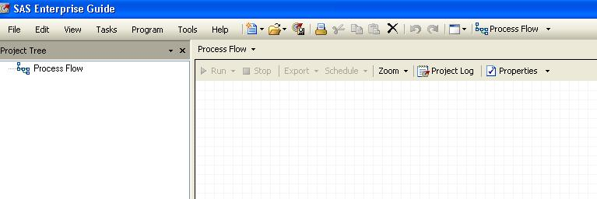

- If you ever lose these windows or if you want to view other available windows, you can retrieve them using the View menu

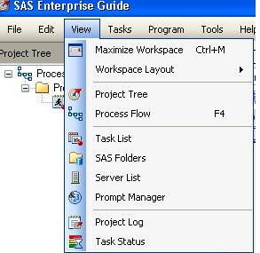

- There are a few housekeeping items you need to take care of the first time you use SAS EG on a particular computer (once these options are changed, they will be preserved): 1. Change the default library (where datasets are stored) to the SAS WORK library (which prevents SAS from saving every dataset you make on your hard drive). 2. Tell SAS to close all open data before running code (you will run into errors if you don’t do this). 3. Turn high-resolution graphics on for custom code (for better graphics).

- To make these changes: Tools→Options
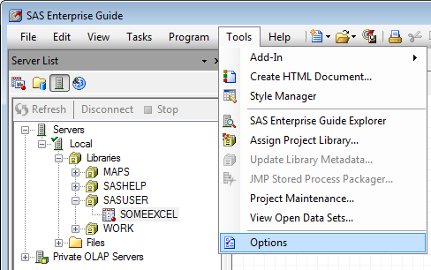

In the left-hand menu, click on Output Library, under Tasks.
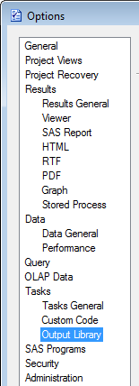

Use the Up key to move the WORK library to the top of the list of default libraries.
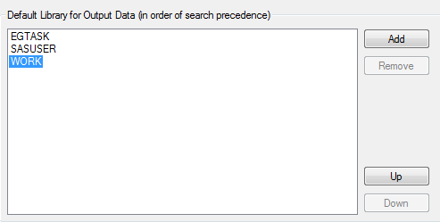
Click 1st
Click 2x

Next, click on SAS Programs in the left-hand menu. Then check the box that says “Close all open data before running code”

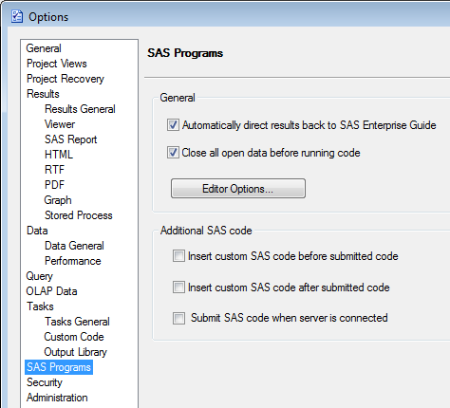
Check this box on

Finally, turn high resolution graphics on for custom code:

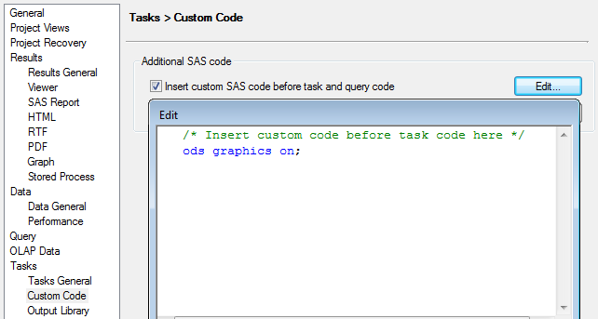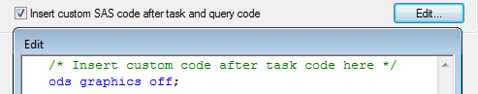

- The first code we are going to write in EG is a simple program to use SAS as a calculator. From the menus, click: Program→New Program

- Type the following in the program window:
data example1;
x=18*10**-6;
put x;
run;
Explanation of code:
This is a SAS “data step.” The first line
tells SAS to create a dataset called “example1.” This dataset will be placed into the “work” library, which is the default temporary library.

data example1;
x=18*10**-6;
Note that each command in a SAS program must be punctuated with a semi-colon. Misplaced or missing semi-colons cause many errors and much frustration in SAS, so pay attention to their placement!
Note that data step or proc in SAS ends with a run statement. The program is not actually executed, however, until you click on the RUN icon.
put x;
run;
Prints the value of x in the SAS log.

Assigns a value to the variable x.
Variable name goes to the left of the equals sign; value or expression goes to the right of the equals sign.

- Click on the run icon.

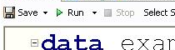

- You should now see three tabs in the program window: program, log, and output data. The log is where SAS tells you how it executed the program, and whether there were errors. The output data is the dataset that we just created.
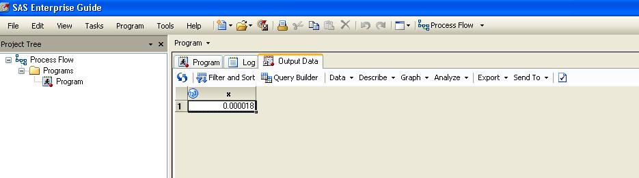

- Start another new program by clicking on: Program→New Program.

- Type the following code in the program window. This code allows you to use SAS as a calculator, without bothering to create a dataset.

data _null_;
Same as above but the “_null_” tells SAS to not bother to make a dataset (e.g., if you just want to use SAS as a calculator).
x=18*10**-6;
put x;
run;

- Check what has been entered into the log. Should look like:

15 data _null_;
16 x=18*10**-6;
17 put x;
18 run;
0.000018
NOTE: DATA statement used:
real time 0.00 seconds
cpu time 0.00 seconds

- Click on the program tab to return to your code. ADD the following code:

Use SAS as a calculator. See Appendix for more mathematical and logical operators.

data _null_; *use SAS as calculator;
x=LOG(EXP(-.5));
Comments (ignored by SAS but critical for programmers and users) may be bracketed by * and ;
Or by /* and */
put x;
run;

- Click on the run icon. The following box will appear. Click “Yes.”

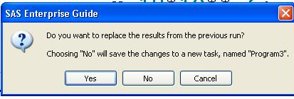

If you clicked “No” SAS would start a new program for you rather than simply updating the old program. In general, it’s easier to keep all your code for a particular analysis within a single program.

- Locate the answer to the calculation within the log window (= -0.5).

- Use SAS to calculate the probability that corresponds to a Z-value of 1.96 (steps: type the following code in the program window, click on the run icon, click yes to save in the same program, click on the log tab to see the answer).

data _null_;
See Appendix for more probability functions.
theArea=probnorm(1.96);
put theArea;
run;

- Use SAS to calculate the probability that corresponds to the probability of getting X=25 from a binomial distribution with N=100 and p=0.5 (for example, what’s the probability of getting 25 heads EXACTLY in 100 coin tosses?):

data _null_;
p= pdf('binomial', 25,.5, 100);
put p;
See Appendix for more probability functions.
run;

- Use SAS to calculate the probability that corresponds to the probability of getting an X of 25 or more from a binomial distribution with N=100 and p=.5 (e.g., 25 or more heads in 100 coin tosses):

data _null_;
pval= 1-cdf('binomial', 24, .5, 100);
put pval;
run;

- Libraries are references to places on your hard drive where datasets are stored. Datasets that you create in permanent libraries are saved in the folder to which the library refers. Datasets put in the WORK library disappear when you quit SAS (they are not saved).

To create a permanent library, click on Tools→Assign Project Library…
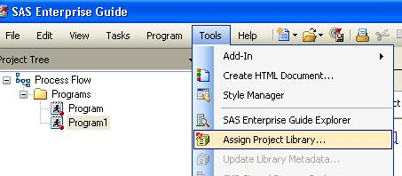

Type the name of the library, hrp261 in the name box. SAS is caps insensitive, so it does not matter whether caps or lower case letters appear. Then click Next.
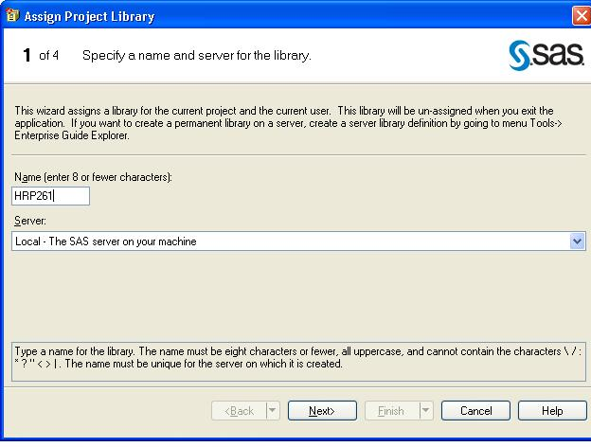

Browse to find your desktop. We are going to use the desktop as the physical folder where we will store our SAS projects and datasets. Then click Next.

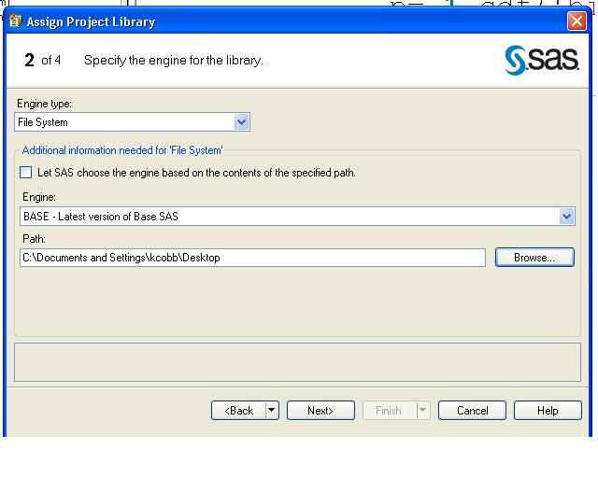

For the next screen, just click Next…

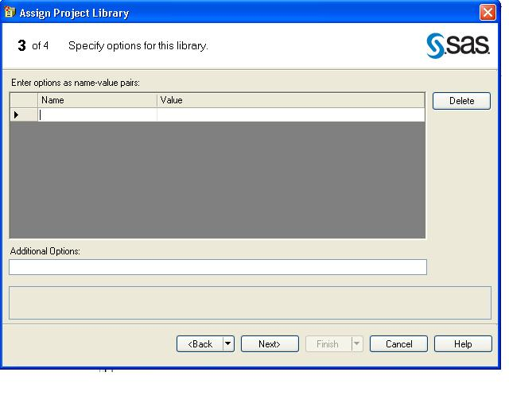

Then click Finish.
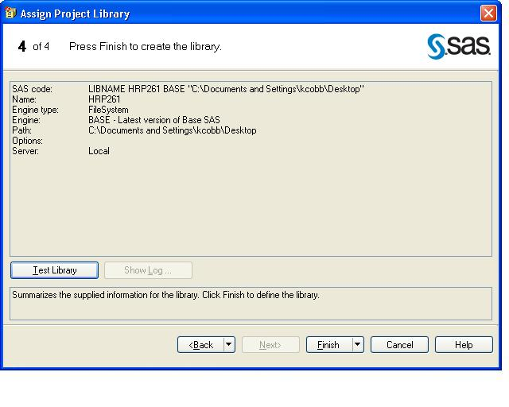

- FYI, here’s the code for creating a library (click on Code tab to see that this code was automatically generated for you). You will need to recreate the library everytime you open SAS—so saving the code or project avoids you having to repeat the point-and-click steps each time.
/**Create Library**/
libname lab1 ‘C:\Documents and Settings\…………\Desktop’;
Location of the folder where the datasets are physically located.

Name the library
Don’t forget the semi-colon!

- Find the library using the Server List window (bottom left of your screen). Double click on “Servers”.
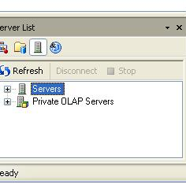

Locate the hrp261 and work libraries (libraries are represented as file cabinet drawers). Double click on the hrp261 library to open it.
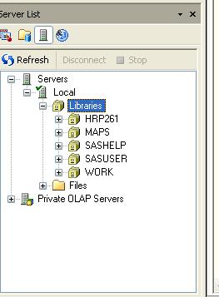

- Start a new program: Program→New Program. Type the following code to copy the dataset example1 into the hrp261 library (rename it “hrp261.example1”):
Makes a new dataset called example1 in the hrp261 library.
Code for moving a dataset, part of a dataset, or a dataset with modifications into a new library.

data hrp261.example1;
set example1;
Starts with the dataset work.example1
x2=x**2;
drop x;
Adds a new variable x-squared to the dataset.
Drops the variable x ; “keep x2;” would have same result.
run;

- Find the dataset in the hrp261 library using the Server List window (bottom left corner).

- Browse to find the example1 dataset in the Desktop folder on your hard drive. This dataset will remain intact after you exit SAS.

- Next, we will input data from a 2x2 table directly into a SAS dataset. These are grouped data from the atherosclerosis and depression example (from the Rotterdam study) in lecture 1/2. Click on File→New→Data to create a new dataset. This dataset will contain 3 variables: IsDepressed (numeric variable), HasBlockage (numeric variable), and Freq (numeric variable).

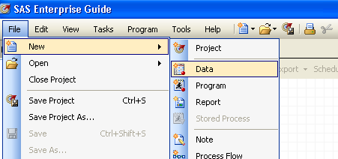

Name the dataset “Rotterdam” and store the dataset in the hrp261 library. Then click Next.
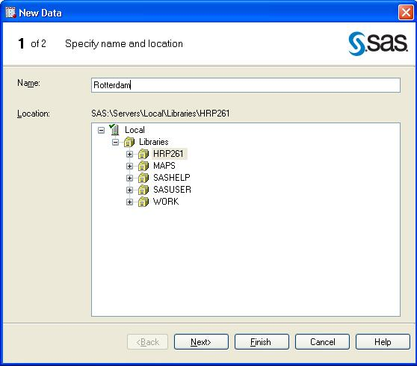

Name a variable “IsDepressed” that is a numeric variable.
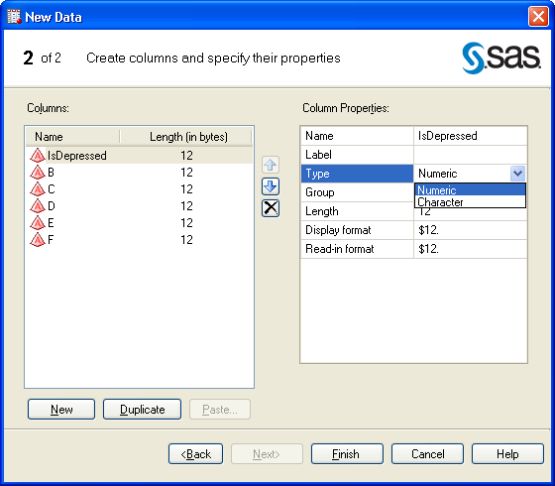

Name a variable “HasBlockage” that is a numeric variable.
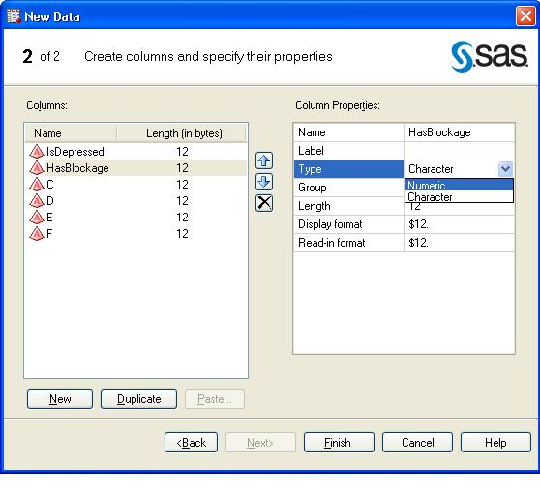

Name a variable Freq that is a numeric variable. Delete variables D, E, and F, which we will not use. Then click Finish.
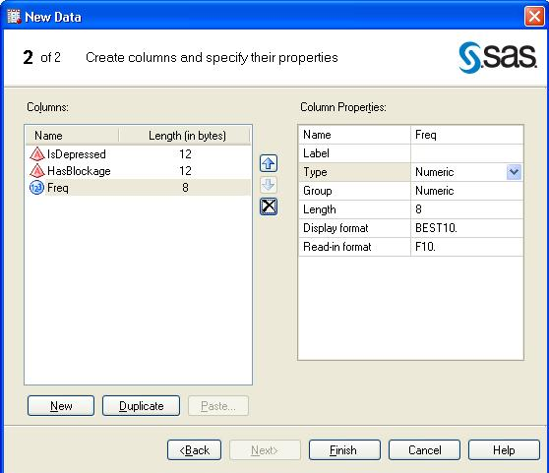

Directly type the following data values into the dataset. Right click on empty rows to delete them.
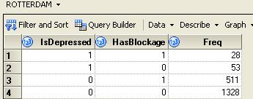

FYI, the code to enter the same data is the following (it’s much faster to type this code than point and click!):
The variable “freq” stores the counts in each 2x2 cell.

data hrp261.Rotterdam;
input IsDepressed HasBlockage Freq;
datalines;
Note use of informative variable names.
1 1 28
1 0 53
0 1 511
0 0 1328
run;

- Generate the 2x2 contingency table using PROC FREQ.
Tells SAS how to ORDER the rows and columns. The default is to use numerical or alphabetical order, which would make cell a the “undepressed, unblocked” cell. Instead, order=data tells SAS to order rows and columns according to the order that the values appear in the dataset (1s before 0s).

proc freq data=hrp261.rotterdam order=data;
tables IsDepressed*HasBlockage /nopercent norow nocol;
weight freq;
run;
Options (optional features) follow a front slash in a SAS procedure.
These options tell SAS to omit the cell, row, and column percents in the 2x2 table.

If you forget the weight statement, SAS will see only 1 observation in each cell of your 2x2 table.

Press RUN to generate results:

Table of IsDepressed by HasBlockage
 |  | HasBlockage |  | Total
 |  | 1 | 0 | Total
IsDepressed |  | 28 | 53 | 81
1 | Frequency | 28 | 53 | 81
0 | Frequency | 511 | 1328 | 1839
Total | Frequency | 539 | 1381 | 1920

- Modify code to request statistics for contingency tables using PROC FREQ.
Asks SAS to present the expected table for the chi-square test.

proc freq data=Rotterdam order=data;
tables IsDepressed*HasBlockage / chisq measures expected;
weight freq;
run;

Options (optional features) follow a front slash in a SAS procedure.
These options tell SAS to present the chi-square statistic as well as measures of association (odds ratios and risk ratios).

Press RUN for results:

Table of IsDepressed by HasBlockage
 |  | HasBlockage |  | Total
 |  | 1 | 0 | Total
IsDepressed |  | 28 | 53 | 81
1 | Frequency | 28 | 53 | 81
1 | Expected | 22.739 | 58.261
1 | Percent | 1.46 | 2.76 | 4.22
1 | Row Pct | 34.57 | 65.43 | Expected counts are highlighted here.
1 | Col Pct | 5.19 | 3.84
0 | Frequency | 511 | 1328 | 1839
0 | Expected | 516.26 | 1322.7
0 | Percent | 26.61 | 69.17 | 95.78
0 | Row Pct | 27.79 | 72.21
0 | Col Pct | 94.81 | 96.16
Total | Frequency | 539 | 1381 | 1920
Total | Percent | 28.07 | 71.93 | 100.00

Statistic | DF | Value | Prob
Chi-Square | 1 | 1.7668 | 0.1838
Likelihood Ratio Chi-Square | 1 | 1.6976 | 0.1926  Chi-square is non-significant.
Continuity Adj. Chi-Square | 1 | 1.4469 | 0.2290
Mantel-Haenszel Chi-Square | 1 | 1.7659 | 0.1839
Phi Coefficient |  | 0.0303
Contingency Coefficient |  | 0.0303
Cramer's V |  | 0.0303

Fisher's Exact Test
Cell (1,1) Frequency (F) | 28  Fisher’s exact is automatically calculated when you request chi-square statistics for a 2x2 table.
Left-sided Pr <= F | 0.9250
Right-sided Pr >= F | 0.1157
Table Probability (P) | 0.0407
Two-sided Pr <= P | 0.2060

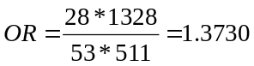
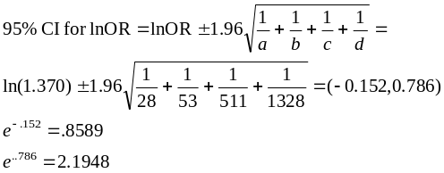

Estimates of the Relative Risk (Row1/Row2)
Type of Study | Value | 95% Confidence Limits
Case-Control (Odds Ratio) | 1.3730 | 0.8589 | 2.1948
Cohort (Col1 Risk) | 1.2440 | 0.9138 | 1.6937
Cohort (Col2 Risk) | 0.9061 | 0.7715 | 1.0642

Probability of also having atherosclerosis if you are depressed:
Probability of NOT having atherosclerosis if you are depressed:

Column1 risk ratio=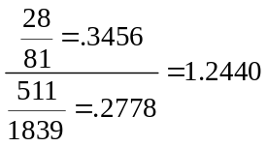
Column2 risk ratio=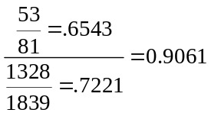

Probability of having atherosclerosis if you are not depressed.
Probability of NOT having atherosclerosis if you are NOT depressed.

- Use point-and-click to generate 2x2 tables and associated statistics. Click on the dataset to open it. Describe→Table Analysis.
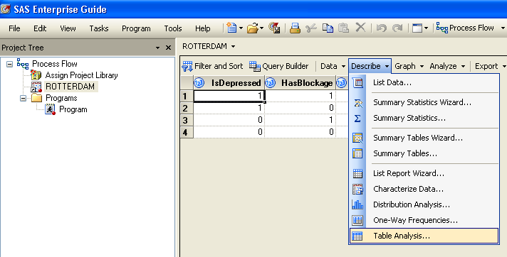

Drag IsDepressed and HasBlockage to be the Table variables; and Freq under Frequency count.
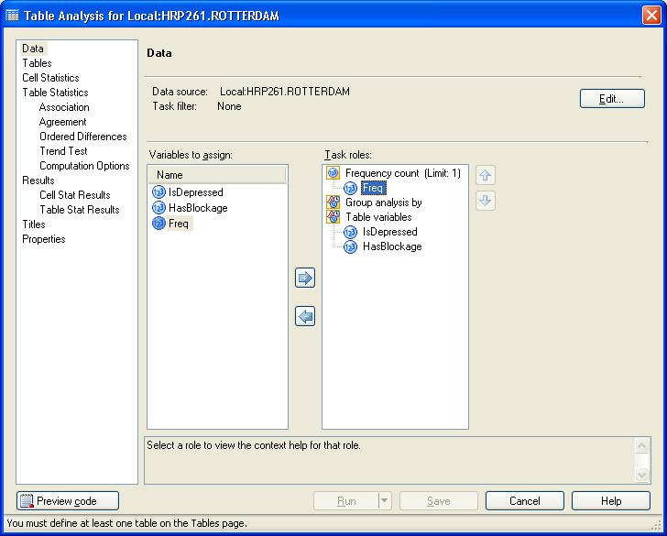

Then click on Tables on the lefthand menu, and drag HasBlockage to be the column variable and IsDepressed to be the row variable.

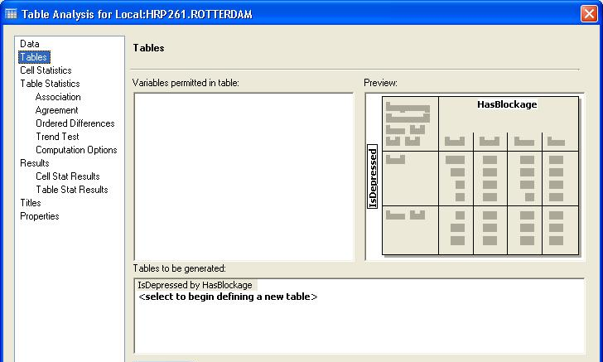

Click on Associations under Table Statistics, and check the boxes for Chi-square, Fisher’s exact, and measures of association.
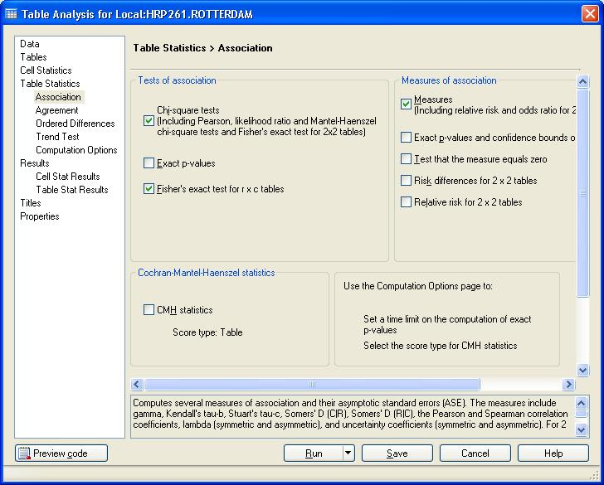
Then press Run.
30. EXTRA: IF YOU GET AHEAD! (OPTIONAL)
A SAS macro is just a function. You can save it for future use, to avoid repetitive coding.
For example, enter the following macro to calculate upper and lower confidence limits for any 2x2 table. The user enters the desired level of confidence (e.g., 95%, 99%, etc.) and the cell sizes from the 2x2 table (cells a-d). The macro calculates the point estimate and confidence limits for the given 2x2 table and enters the results into the SAS LOG.
 | Has outcome | No  outcome
Exposed | a | b
Unexposed | c | d

- A % sign in SAS denotes a macro name.
- In SAS, a variable bracketed by & and . (e.g., &a.) denotes a macro variable (entered into the macro by the user).
When creating a macro, it’s important to include detailed comments that instruct a new user on how to use your macro.
/**MACRO to calculate XX% confidence limits for an odds ratio
for a given confidence level (entered as a whole number, eg “95”)
and the 2x2 cell sizes: a,b,c,d, where a is the diseased, exposed
cell**/

%macro oddsratio (confidence,a,b,c,d); *enter confidence
percent as a whole number, e.g. "95";
data _null_;
OR=&a.*&d./(&b.*&c.);
lnOR=log(OR);
The probit function returns the Z score associated with a given area under a normal curve.
error=sqrt(1/&a.+1/&b.+1/&c.+1/&d.);
Z=-probit((1-&confidence./100)/2); *gives left hand
Z score, multiply by negative;
lower=exp(lnOR-Z*error);
upper=exp(lnOR+Z*error);
put OR;
put lower;
put upper;
run;
%mend oddsratio;

/**Invoke MACRO using data from depression/atherosclerosis example and ask for 95% confidence limit**/
%oddsratio(95, 28, 511, 53, 1328);
 | Depressed | Not
Atherosclerosis | 28 | 511
None | 53 | 1328

SAS LOG should contain:
1.3729645903
0.8588505235
2.194831015
APPENDIX A: Some useful logical and mathematical operators and functions:
Equals: = or eq  Not equal: ^= or ~= or ne  Less then: < or lt, <= or le,  Greater than: > or gt, >= or ge, | ** power  * multiplication  / division  + addition  - subtraction
INT(v)-returns the integer value (truncates)  ROUND(v)-rounds a value to the nearest round-off unit  TRUNC(v)-truncates a numeric value to a specified length  ABS(v)-returns the absolute value  MOD(v)-calculates the remainder | SIGN(v)-returns the sign of the argument or 0  SQRT(v)-calculates the square root  EXP(v)-raises e (2.71828) to a specified power  LOG(v)-calculates the natural logarithm (base e)  LOG10(v)-calculates the common logarithm

APPENDIX B: Some useful probability functions in SAS

Normal Distribution
- Cumulative distribution function of standard normal:
P(X≤Z)=probnorm(Z)
- Z value that corresponds to a given area of a standard normal (probit function):
Z= φ(area)=probit(area)
- To generate random Z → normal(seed)

Exponential
- Density function of exponential (λ):
P(X=k) = pdf('exponential', k, λ)
- Cumulative distribution function of exponential (λ):
P(X≤k)= cdf('exponential', k, λ)
- To generate random X (where λ=1)→ ranexp(seed)

Uniform
P(X=k) = pdf('uniform', k)
P(X≤k) = cdf('uniform', k)
To generate random X → ranuni(seed)

Binomial
P(X=k) = pdf('binomial', k, p, N)
P(X≤k) = cdf('binomial', k, p, N)
To generate random X → ranbin(seed, N, p)

Poisson
P(X=k) = pdf('poisson', k, λ)

P(X≤k) = cdf('poisson', k, λ)

