CEE 224A: END OF QUARTER REPORT

CAMPUS WIND MONITORING PROJECT / FEASIBILITY STUDY FOR BUILDING INTEGRATED
WIND TURBINES

Submitted by Jordan Shackelford
Masters student in Civil and Environmental Engineering
Atmosphere / Energy Program, Stanford University

Faculty Mentor: Dr. Mark Jacobson
Director, Atmosphere / Energy Program, Stanford University

12 / 15 / 2006

Executive Summary 1
End of Quarter Report 2
Project Goals Defined 2
Methods 3
Collection of Campus Wind Data 4
Preliminary Data Analysis 5
Acquisition and Installation of Wind Monitoring Equipment 6
Short Review of Building Integrated Wind Turbine Technology 9
Early Conclusions and Next Steps 11
Appendix 13
Research Proposal and Budget: 13
Additional Data Analysis Results: 15

Executive Summary

This is an exciting time for wind in the United States. The wind power industry is growing at an astounding pace of 40 percent per year in installed capacity as the electricity industry seeks to diversify energy supply to meet the changing demands of the market and of local, state, and federal regulations. These new demands are the result of a complex array of developments such as wind’s increasing competitiveness due to evolving technology, heightened attention to energy security and independence, and even broader concerns about the global impacts of climate change. It is in this milieu that several students have endeavored through the Fall Quarter of 2006 to take a closer look at wind in their own “backyard,” the campus of Stanford University. This has culminated in the organization of the Atmosphere / Energy campus wind project team, a student group working together to explore wind on campus and to examine the potential of harnessing wind locally for power generation on small and large scales.
Within the activities of this group and through the guidance and support of the Stanford Green Dorm Sustainable Development Studio, the specific independent research project described here attempts to characterize wind over the built environment on campus and to examine the feasibility of building integrated wind turbine applications. This project is advised by faculty mentor Dr. Mark Jacobson, director of the Atmosphere / Energy program in the Civil and Environmental Engineering Department of Stanford University.
This paper outlines research goals and methods, and also reports on achievement of project goals to date. A discussion of the results of preliminary campus data analysis is presented, which is followed by a brief review of building integrated turbine technologies with a focus on “urban turbine” designs from manufacturers AeroVironment and Quiet Revolution. Further goals for this ongoing research project are stated at this report’s conclusion.

End of Quarter Report

Project Goals Defined
This report is intended to summarize the progress and results to date of the Campus Wind Monitoring Project / Feasibility Study for Building Integrated Wind Turbines currently being carried out on Stanford University’s campus. This project, while termed an independent study, represents one student’s efforts in the context of cooperation amongst several students working on issues of wind monitoring and campus wind power. This cooperation joins the efforts of the Atmosphere / Energy campus wind project team with those of Stanford’s Green Dorm Sustainable Development Studio. The Green Dorm’s involvement in this research, from funding support to project development, is an integral feature of the work described here.
Occasionally when the efforts other individuals are represented herein, specific attributions are made, but in general, contributions by the following colleagues are acknowledged as having been invaluable to this project’s successful execution:
Atmosphere / Energy Associates Stanford Green Dorm
Jordan Wilkerson Jonas Ketterle
Bret Dietz
Tyler Heubner

Current and proposed activities of the campus wind group are manifold, and include the following:
- to inventory wind data from campus weather stations
- to monitor and characterize the campus wind resource for building integrated applications
- to explore methods for measuring and calculating wind speeds aloft, at altitudes where a commercial size turbine might operate; technology considered has included tethered balloons, sodar and lidar type profiling technology, and meteorological towers of 50 to 60 meter heights
- to explore other areas of interest related to wind monitoring and wind power in and around the Stanford area; such as modeling and mapping of the wind resource at various elevations, and comparing such models to observations from monitoring stations

The subject of the research presented in this report is an extension of the campus wind group’s efforts, particularly in the first two areas mentioned above. Namely, this project focuses on monitoring wind speeds on rooftops around campus to assess the viability of integrated wind turbines in this area. Building-integrated wind power that takes advantage of air flow over the built environment represents a promising new technology that can provide clean and reliable energy locally. Research and development for such technology is still in its nascent stages, but market developments have recently come online that may radically change the face of green energy in the urban environment. In order to consider applying the concepts of this growing field to the local level, wind research on campus is required. Over the course of the Fall Quarter of 2006, research has centered around:
- Acquiring campus wind data from all possible sources
- Obtaining reliable measuring instruments for recording of wind speed / direction on campus rooftops to record constant time-series information
- Research turbine technology and siting criteria, identifying the best locations for wind monitoring on campus, with particular attention paid to the future location of the Green Dorm

Methods
As much of this research is team based, it was decided early on that regular project meetings and communications be established in order to facilitate cooperation amongst participants. At the beginning of the quarter, weekly meetings were organized and a group email listserv was set up. Later in the quarter, smaller focus meetings and more frequent communications have been the standard, as campus wind group members familiarize themselves with use of the monitoring equipment, data retrieval from the data loggers, and design and siting of rooftop monitoring stations.
Information being considered by this research includes wind information already gathered by various campus stations and observations currently being recorded at the rooftop monitoring site that this project has established. As data is received, it is compiled into various spreadsheets for analysis and interpretation. A compilation of five to ten minute averaged data as well as daily averages for wind speed and direction in some instances has thus been organized. This collection will be complemented by additional monitoring data to be obtained from stations installed during research. Analysis of the data includes frequency distributions, comparison with calculated ideal Rayleigh distributions, and power density calculations for frequency distributions. Such analysis is performed manually in Excel spreadsheets as well as through the use of a set of macros designed for interpreting wind data for wind energy studies. These tools, which perform tasks such as making wind roses to represent wind direction distributions as well as graphing of diurnal wind speed variations and yearly frequency distributions, were obtained from Idaho National Engineering and Environmental Laboratory.

Collection of Campus Wind Data
One of the primary objectives of this study was to assemble as much of the available wind information on campus as possible. The purpose of compiling existing wind data from various sources is to give a better understanding of the wind resource in and around Stanford. It was known that several meteorological stations are or have been operated by various groups on campus. The following represents the known sites where wind information is or has been recorder:
- Stanford Weather Station (2005 – present)
- Ground Services weather station (2001 – 2004)
- The Conservation Biology Department’s Foothill’s weather station
- Jasper Ridge Biological Preserve weather station
- STAR lab “Dish” weather station

During a “reconnaissance mission” to the observation deck of Hoover Tower to assess potential campus rooftop monitoring sites, it became apparent that several anemometers are already installed on buildings around campus. Preliminary contacts are being made with the departments thought to be responsible for these anemometers (Mechanical Engineering and Biology) and it is hoped that in the next quarter data from these anemometers can be added to the catalogue of wind data that this project is compiling.
To date, data has been received from the Stanford Weather Station in five minute averaged intervals for 2006 (through October), from the Grounds Service’s station as daily averages for 2001 – 2004, and from the STAR lab “Dish” weather station in ten minute averages for 2005. Requests are still pending at some stations and it is anticipated that with the help of Civil and Environmental Engineering professor Dr. David Freyberg, data from the Jasper Ridge Biological Preserve station should be forthcoming shortly.

Preliminary Data Analysis
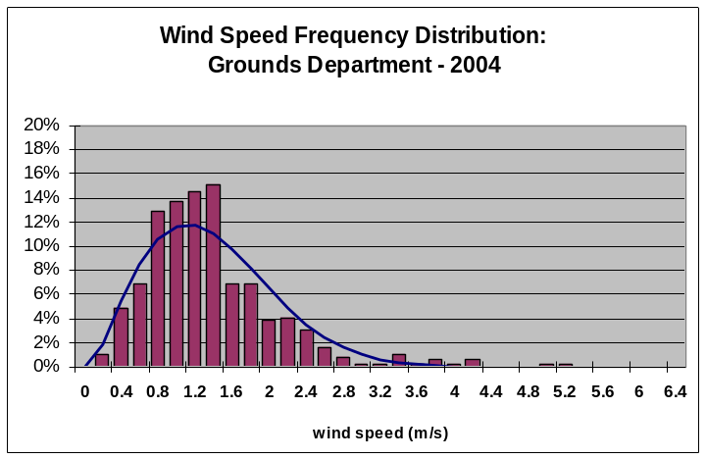
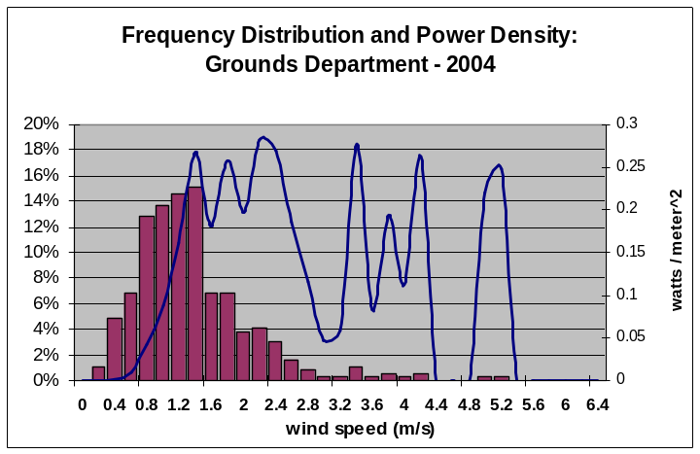
The following is an example of analysis of wind data being performed on all campus wind data received. Analysis of campus data is still ongoing and is incomplete so far. Figures I and II represent daily wind speed averages from the Ground Services station in 2004. Similar analyses are underway for other locations. Notice that an ideal Rayleigh distribution curve has been overlain on Figure I, which demonstrates that the frequency distribution at this site is fairly close to the expected Rayleigh distribution.
Figure I: Frequency distribution and Rayleigh curve: Figure II: Frequency distribution and power density
Ground Services – 2004 calculation: Ground Services - 2004
This probability curve was calculated from the following equation:

Prob. (Windspeed < v) = 1 – exp[(-π/4)(v/v_{average})²]

Figure II demonstrates the increase in power density of the wind with increased velocity according to the proportional relationship between power and the cube of wind speed. This figure demonstrates that even though the higher velocities occur much less frequently, they account for most of the available wind power at a site such as the Ground Services site. Total average annual power density for the site was 3.6 w/m².
The appendix to this report includes some additional results from analyses of 2005 ten minute averaged data from the STAR lab “Dish” station and from five minute averaged data from Stanford Weather Station for 2006. Frequency distributions and power densities were done manually in Excel, while diurnal wind plots and the wind rose were made with the Excel macros. As the macros are a new and somewhat unfamiliar tool, there is still some uncertainty as to the validity of calculations performed by them; further tests are being run to verify results.

Acquisition and Installation of Wind Monitoring Equipment
Another principal goal of this study was to take actual wind speed and direction measurements on rooftops around campus. In order to fulfill this goal it was necessary to obtain good wind measurement equipment from a reliable manufacturer. Specifically, several anemometers, wind vanes, and data loggers were necessary to conduct the desired research.
The first choice for monitoring equipment was a loan program from a local or state agency. It was discovered early in the project that many states around the country actually have quite robust programs for lending anemometers to individuals or organizations seeking to assess wind resource in a given location. Many such programs were reviewed, including one on the books for the state of California. Unfortunately, California’s anemometer loan program is stalled due to funding constraints, and no suitable alternative was discovered, so purchase of equipment was seen as necessary. Funding for the purchase of monitoring equipment was fortunately secured by a grant from the Green Dorm’s student research fund. A quantity of roughly $3,000 was made available to use towards instruments and installation hardware, which amount is reflected in the project proposal and budget appended to this report.
A variety of options exist in the marketplace for wind speed measuring instruments, so a thorough review of the choices in anemometers was necessary before any purchases could be made. After looking into various makers of wind equipment, the manufacturer NRG Systems was chosen as the vendor for anemometers, wind vanes, and loggers for this project. This manufacturer was chosen because their anemometer models stand out as “industry standard” equipment used in the field for research and commercial development around the world. In fact, many of the state anemometer loan programs mentioned currently use NRG Systems instruments. Once NRG Systems was selected, contact was established with sales personnel. After several communications regarding the nature of the research project, a 30% discount was secured towards academic purchases by the campus wind project group. Through Green Dorm funding, four anemometers, loggers and data plugs, and weather vanes were then ordered from NRG Systems. The transaction took several weeks from initial contact to order and receipt. The shipment was received on November 13, 2006.
During the equipment acquisition process, the previously mentioned “reconnaissance mission” by wind group team members was undertaken to locate potential rooftop monitoring sites. Several preferred sites were identified, among them Hoover Tower itself. Other preferred rooftops included Meyer Library due to its central campus location; a row house near the future site of the Green Dorm, such as Casa Italiana or Xanadu; Blackwelder Residence, due to its height and ease of access; and the Stanford Stadium, also due to its height. The process of requesting permission for anemometer installation was then initiated with much assistance from Jonas Ketterle. In short order, provisional approval from Stanford Student Housing was granted for Xanadu. Facilities management also approved the use of Meyer Library’s roof for a monitoring station.
An initial meeting with facilities staff took place at Xanadu on November 7 to discuss the project, its goals, possible impact on the buildings, and design ideas for mounting elevated anemometers on rooftops. A second meeting followed to actually step foot on the roof and assess the site. Several wind group members convened on the Xanadu rooftop to share ideas for the best placement and design of systems for the anemometer/wind vane mast, logger wiring, and grounding.
Once the first site had been thoroughly reviewed, a stand system was engineered with crucial assistance from Jordan Wilkerson, who ran stress and strain calculations to evaluate force, sheer, and safety factors. Ultimately, many assumptions had to be made, as it was not possible to include consideration in the rough calculations for components like joints and connections between various materials employed in the actual system. On site engineering and ad hoc strength testing was carried out and backup guy-lines were installed to prevent any potential danger from failure of the mast system.
Materials for the stand were then purchased at a local hardware store. The system consists of a ten foot, two inch thick PVC pipe upon which the anemometer is mounted. The wind vane is mounted on an extension two feet below the anemometer to minimize interference. For comparison with the elevated observations the Xanadu system has an additional anemometer installed on a ground level extension off of the main mast which reaches right to roof’s edge. The data loggers are installed inside Xanadu, and are wired through the attic and a vent to the station base and up through the PVC mast to the individual instruments (see Figure III).
Recording of wind speed and direction at the Xanadu site began on December 7. The site has since been visited and observations made to assure that everything is functioning properly. The first visit for preliminary data collection and equipment check up will likely occur around the 15th of December, 2006. Subsequently, data collection visits will occur every two to three weeks, and received data will be added to the wind data compilation for review and analysis as the project continues.
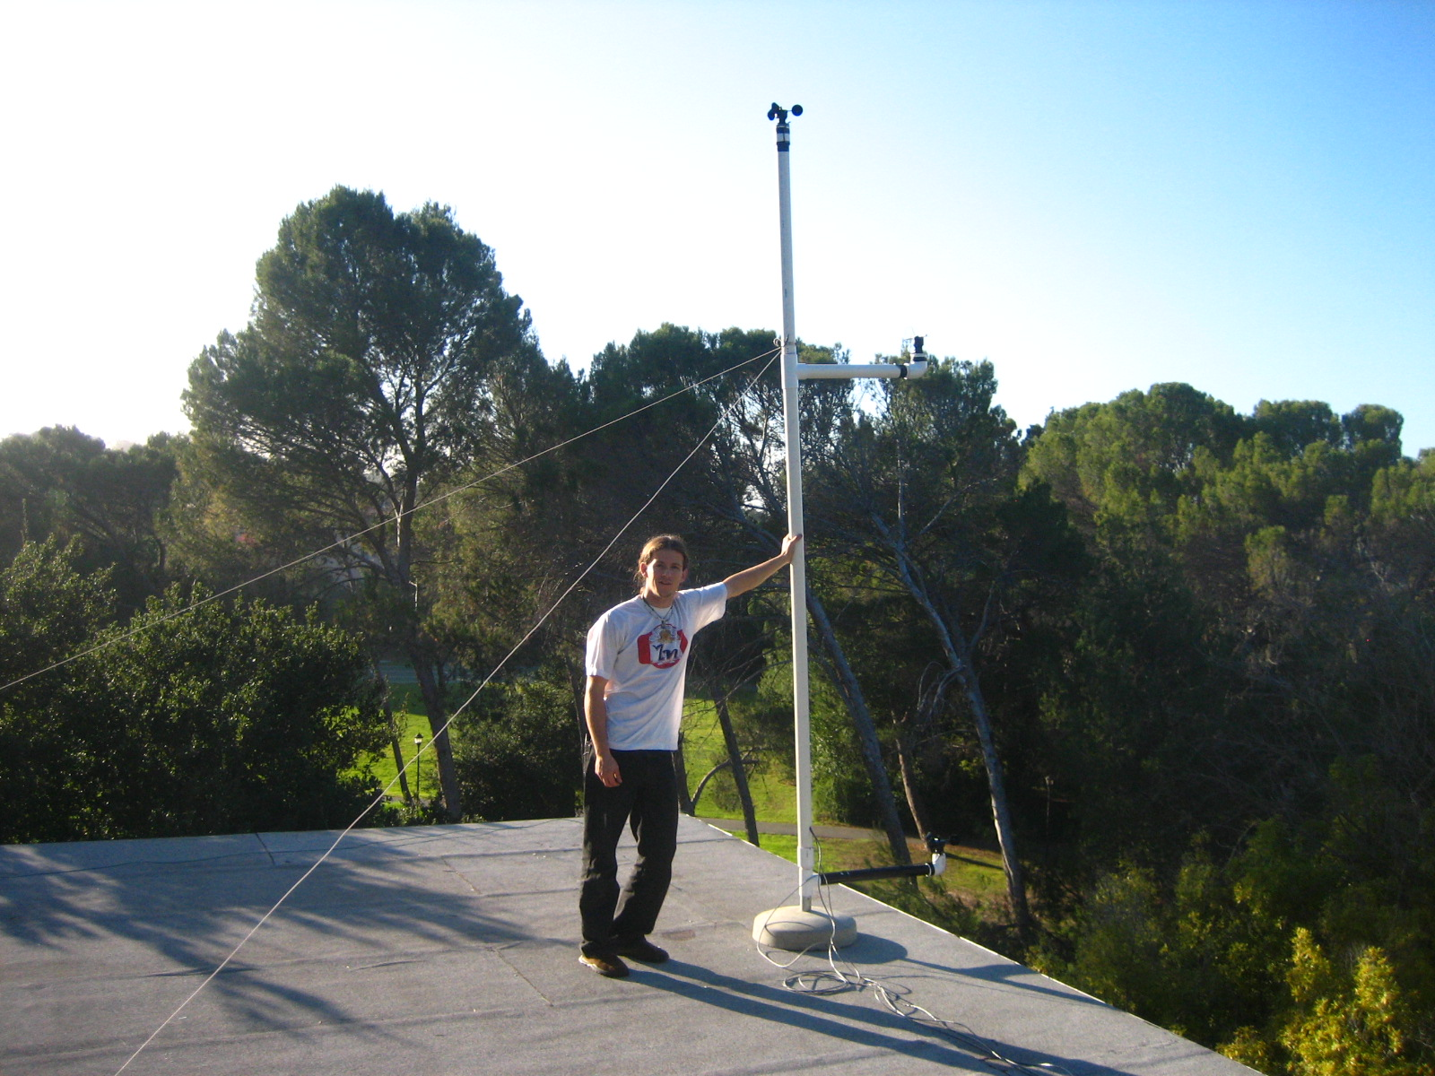
Figure III .Jordan Shackelford with completed Xanadu wind monitoring station Photo credit: Tyler Huebner

Short Review of Building Integrated Wind Turbine Technology
Turning to building integrated wind turbines, there are several technologies currently in development or in production for the purpose of harnessing the power of wind in the built environment. This review will focus briefly on two of the most promising designs currently on the market. One manufacturer, Monrovia, California based AeroVironment, is located close to the study area. Their Architectural Wind branch has recently launched turbine model AVX400 (shown in Figure IV), engineered to take advantage of airflow over the parapet of urban structures. These 400 watt rated turbines are sold as 15 unit arrays to provide an average 6 kW of power. They are designed to be minimally intrusive and quiet, and are able to begin operating at cut in speeds as low as
2 m/s or less. This low cut in speed is intended as much for the “aesthetic of motion” as for power production.

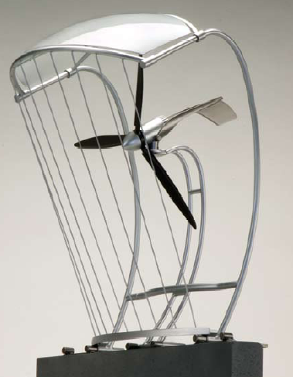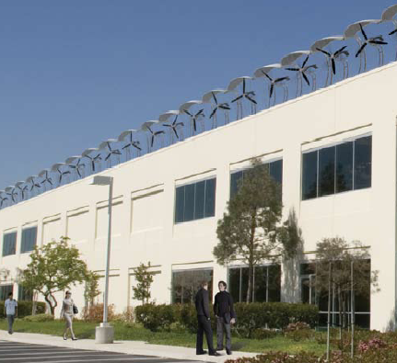

Figure IV: AeroVironment’s AVX400

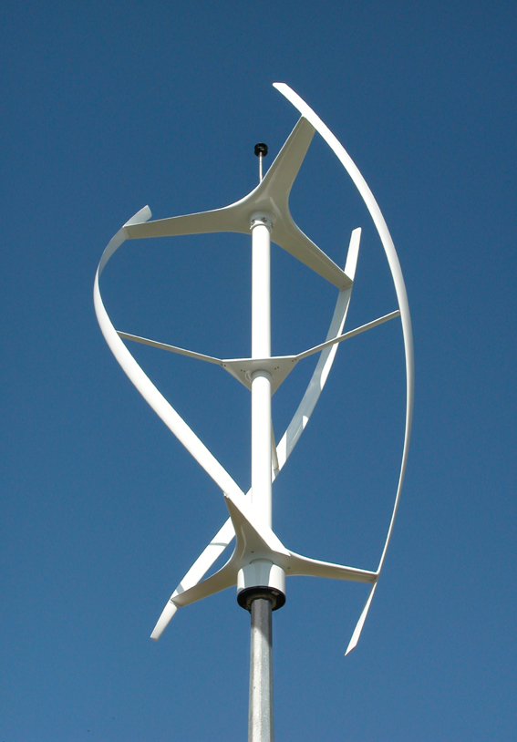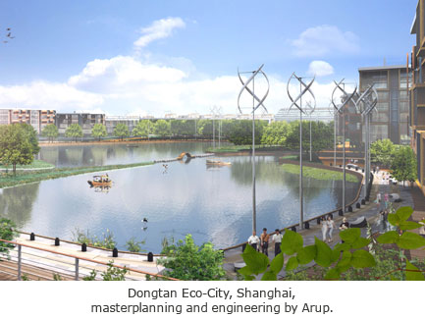
Figure V: Quiet Revolution’s QR5

One of the other significant integrated turbine designs currently on the market is the English manufacturer Quiet Revolution’s QR5. The QR5 (shown in Figure V) uses a vertical axis design with three helical blades to capture wind from any direction. The QR5 is constructed of light carbon and similar to the AVX400 is designed to minimize noise and vibration. Significantly, though the QR5 shares many power and energy output characteristics with the AVX400, it has a much higher cut-in speed of 4 m/s. From the frequency distribution reviewed previously, this high cut in speed could severely affect power output. For a full comparison of the two designs, see Table I.
Once sufficient data for wind characteristics over rooftops on Stanford’s campus is compiled, it is hoped that designs such as the AVX400 and the QR5 can be evaluated for their potential in light of the local wind resource. Such evaluations are problematic to make at this point in the project due to the dearth of data.

 | AVX400 | QR5
Power output | 6 kW  (15 unit array) | 6 kWt
Annual energy | 10,000 kWh | 9,600 kWh
Cut in speeds | Less than 2 m/s | 4 m/s
Cost | $34,500 | $60,000
Weight (kg) | 91  (per unit) | 250
Dimension (m) | 1.2x1.2x1.2 | 5x3x3
Table I. Comparison of Building Integrated Wind Turbine Designs

Early Conclusions and Next Steps
Though this research is very much a work in progress, the experience thus far has proven incredibly worthwhile. Much has been learned about the process of collecting and analyzing the types of information important for a complete wind resource study. Preliminary data analysis is beginning to form a rough picture of the wind conditions on campus; further data collection and analysis will increase the resolution of this picture. Successes in the areas of acquiring monitoring equipment and installment of a dual anemometer rooftop monitoring station at Xanadu are encouraging. On the other hand, much work still remains in order for the project to continue to progress towards achievement of all of the goals laid out at the beginning.
Few solid conclusions can be made based on results to date, as many crucial steps are still being taken. These include gaining access to additional rooftops on campus, installation of additional monitoring sites, and collection of observations from rooftop sites for analysis. A more complete suite of wind information will allow for more conclusive evaluations of the campus wind resource. It is anticipated that at least one to two more quarters of work and monitoring are necessary for this evaluation to take place.

Topics for further research under consideration by the campus wind project group include:
- Investigating wiring, grid connection and power storage issues for integrated turbines
- Designing a low cost tethered balloon system for taking periodic wind speed measurements aloft
- Developing a longer term strategy for siting of wind monitoring equipment for full sized wind turbine
- Estimating wind speeds aloft through least squares extrapolation, using measurements taken at varying altitudes to estimate roughness coefficients for calculations
- Making use of wind data compiled from various points throughout campus to construct aerial map of wind resource over greater campus area

Appendix

Research Proposal and Budget:

CEE 124/224A:Sustainable Development Studio
Student-Faculty Research Proposal
Student Name: | Jordan Shackelford
Faculty Mentor Name /Department: | Dr. Mark Jacobson
Number of Units to be Assigned (1-5): | 2
Grading Basis (Letter or P/NC): | Letter
Research Topic: | Wind monitoring and feasibility study for campus wind turbine
Team based research will focus on the following areas:
- Locate, obtain measuring instruments for recording of wind speed / direction at selected sites, research wind monitoring methodologies
- Research turbine siting criteria to identify best locations for wind monitoring on campus, evaluate logistical and political considerations
- Inventory current weather data from campus weather stations
- Research turbine technologies, including integrated turbine designs, to determine best fit for campus use
Schedule and Deliverables
(Targets and progress by key check-in dates)
Oct 12: Research Methods Defined: Formation of wind project group, data collection from campus weather stations, basic research on turbine technologies and siting methods, research monitoring equipment and methodologies, investigate borrow or purchase of appropriate instruments
Oct 19:
Divide tasks, define project boundaries. Preliminary research on monitoring equipment, siting, and turbine technology. Contact wind experts on campus
Oct 26:
Continue project group meetings, select anemometers for rooftop mounting, dialogue with facilities personnel to secure rooftop access
Nov 2: Preliminary Results (reasonalble, accurate, need to change methods?)
Report on progress in target research areas, select and prepare monitoring sites
Nov 9: Mid-quarter Deliverables
Compile spreadsheet of campus weather station data, monitoring technology and progress brief, secure anemometers, begin mounting and testing
Nov 16:
Continue review of integrated turbine technology, draft recommendations
Nov 30: Continued data collection
Dec 7:
Final report on findings, recommendations, and timetable for further research
Dec 14: End of Quarter Presentation
Student Signature: ______________________________________

Mentor Signature: _______________________________________
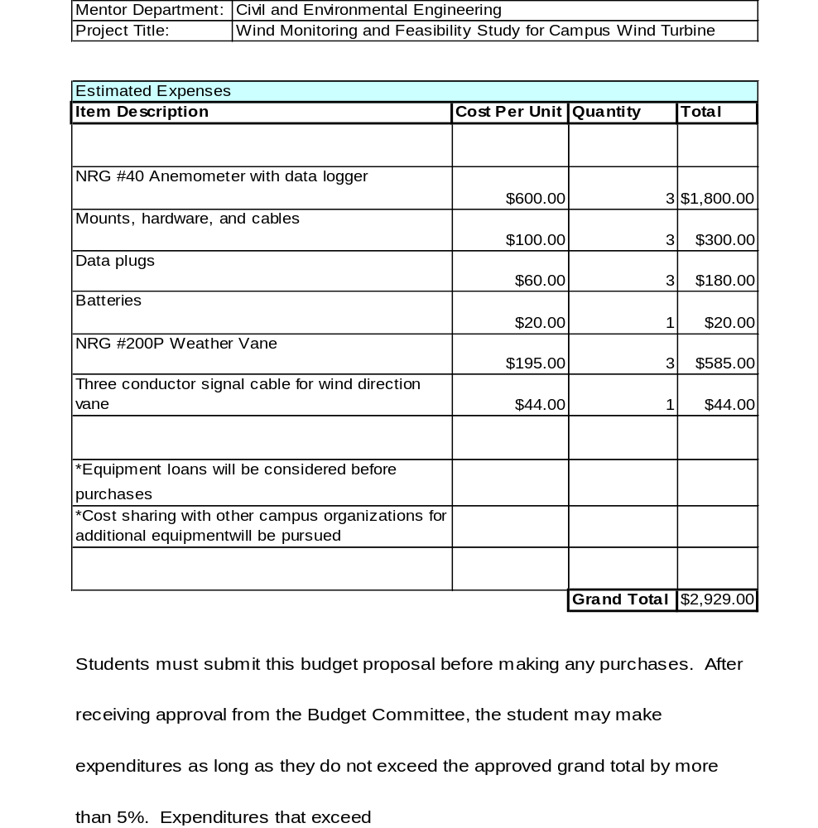

Mentor Signature: _______________________________________

Additional Data Analysis Results:

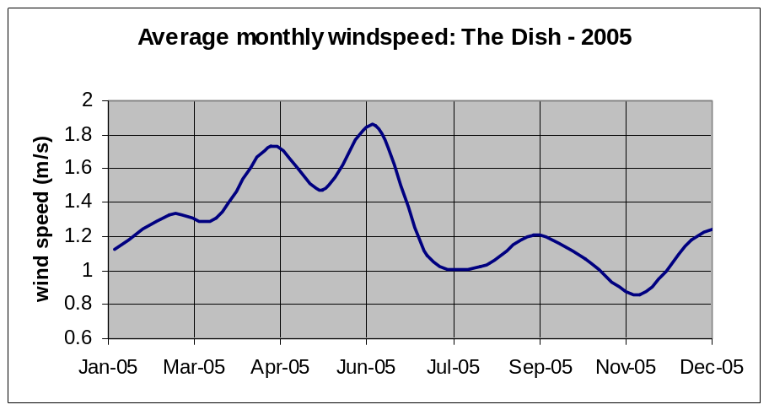
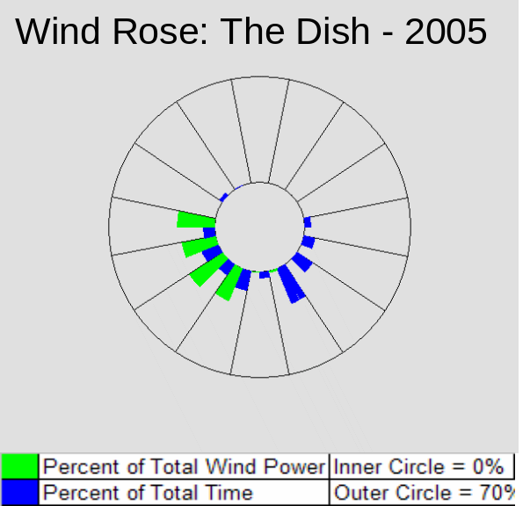
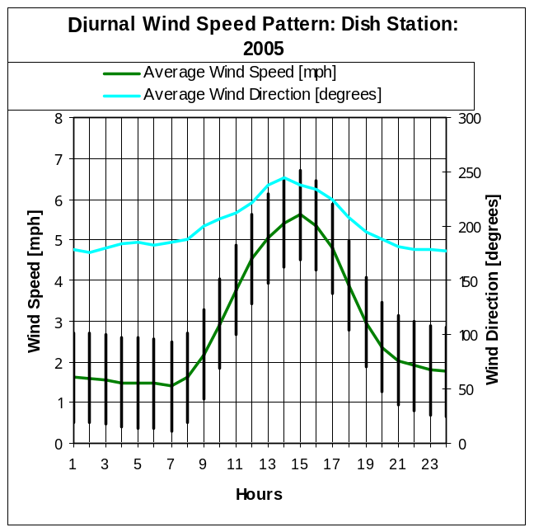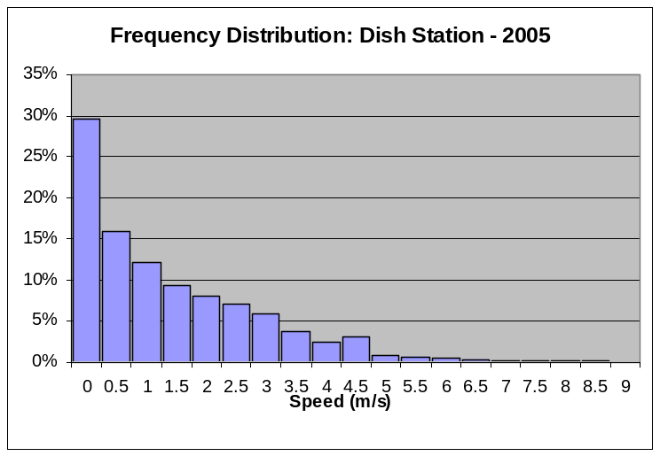

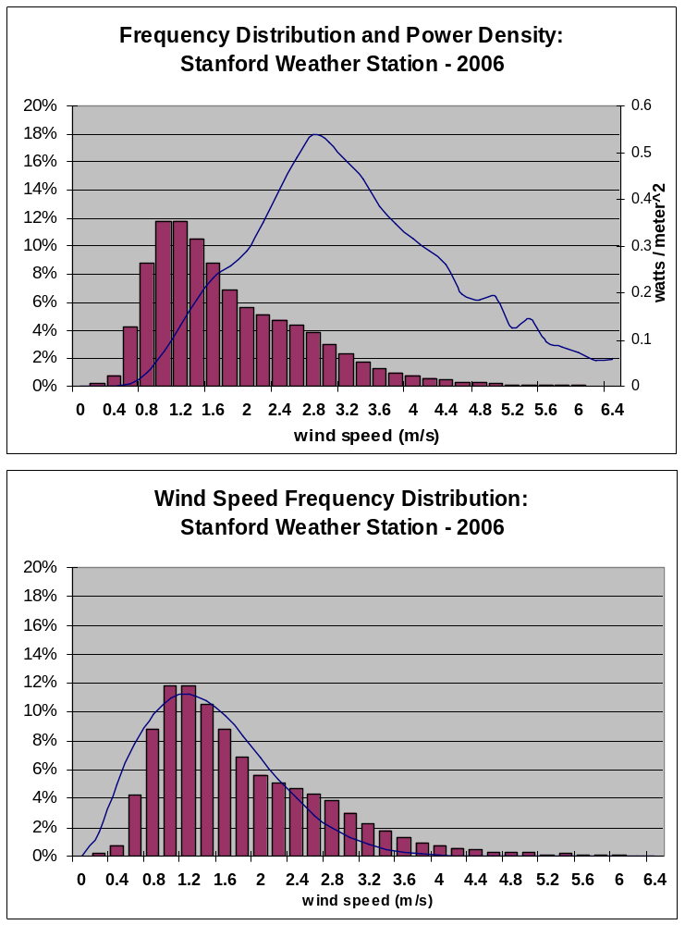

Global Wind Energy Council press release: Record year for wind energy: Global wind power market increased by 40.5% in 2005. Brussels. February 17, 2006. http://www.gwec.net/uploads/media/06-02_PR_Global_Statistics_2005.pdf
The Green Dorm’s Sustainable Development Studio course; CEE 224, is “a project-based independent study course that investigates sustainable design, development, buildings and connections to broader resource systems. Research areas include architecture, building materials, information design, education, energy systems, water, air and food.” More information is available at http://www.stanford.edu/group/greendorm/participate.html
Idaho National Laboratory’s wind analysis spreadsheet with macros; prepared by Matthew West. Available at http://www.inl.gov/wind/software/
Available at: http://grounds.stanford.edu/topics/weather.html
Equation from lecture presentation: Power: Energy Options for a Global Society. Renewable Energy Principles and Applications II: Wind & Geothermal Power. From website of Beth Ellen Clark Joseph. Assistant Professor, Department of Physics. Ithaca College. available at: www.ithaca.edu/faculty/bclark/TREEA/MISC/Renewable_Energy_Wind_Lecture.ppt
AeroVironment Product Website. Architectural Wind Brochure. available at: http://www.avinc.com/publish/2006/10/11/1084_Brochure_-_Architectural_Wind_06_0919.pdf
Quiet Revolution Product Website: Documents QR5 Mass and Loads, General Design and Mounting Info. available at: www.quietrevolution.co.uk

