A HYBRID EDGE-ENHANCED MOTION ADAPTIVE DE-INTERLACER

Marc Ramirez
Stanford University, EE392J Final Project

ABSTRACT
Many methods have been proposed to perform high quality de-interlacing but few of them are computationally efficient enough to be implemented in a fast software application. In order to come closer to this goal, this paper discusses a non-motion compensated (Non-MC) hybrid de-interlacer which benefits from a proposed HDTV de-interlacer and the idea that jagged edges can be improved with additional processing.

PROBLEM STATEMENT
This project involves implementing a high fidelity, Non-MC de-interlacer which is robust to a variety of different types of motion. Although recursive motion-compensated de-interlacers provide the highest quality outputs in general, I felt that implementing such an algorithm would be more of a project in accurate motion estimation and would require too many computations per pixel for the given application. For example, high quality MC de-interlacing schemes generally require sub-pixel accuracy for the motion vectors and should represent the “true motion” of the objects [1]. In addition, this algorithm is being developed with the intention of being used to de-interlace some of my own 60i video sequences into a 30P output. Initially, I developed independent ideas on how to de-interlace, but after reading an overview paper by Gerard de Haan of Philips, I was led to an algorithm very similar to the one I had in mind [2]. Haan also published a method to improve the jagged diagonal edges that normally occur in all types of de-interlacers [3]. This component was looked into to add an additional level of quality to the application.

MOTIVATION
The motivation for a high-quality, computationally efficient de-interlacer stems from my experience making home movies of traveling, friends, and family. Generally, these movies are captured using a 3-CCD NTSC Canon GL1 camcorder operating in its pseudo-progressive Frame Mode. The exact details of how the camera performs its de-interlacing while in Frame Mode are unknown to me except for the fact that it merges the data captured on the green CCD of one field with the red and blue CCD data of an adjacent field. The results are typically satisfying except where little or no motion occurs in the scene.

The following images illustrate a zoomed resolution test on the Canon GL1 at 7 feet and adjusted to fill the full frame [4]. The image on the left is from a tripod-mounted camera in Normal (Interlaced) Mode while the one on the right is from Frame Mode [4]. Hopefully it can be seen that there is a slight reduction in the vertical resolution while operating in Frame Mode (~ 320 lines per frame) compared to Normal Mode (~ 420 lines per frame).

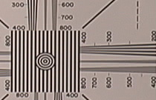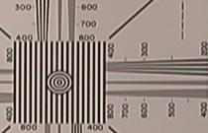
Figure 1: GL1 Resolution Test in Normal Mode.
Figure 2: GL1 Resolution Test in Frame Mode.

INITIAL ALGORITHM
The algorithm published by Simonetti et al., builds on an inherently adaptive algorithm involving a median filter and has shown promise for High Definition TV applications. Additionally, the method uses a hierarchical three-level motion detector to select the type of Non-MC de-interlacing to use on a pixel by pixel basis. The detector distinguishes between static pixels, low-motion pixels, and high-motion pixels [5].

As mentioned previously, an edge-dependent de-interlacer (EDDI) proposed by de Haan can yield significant improvements in jagged diagonal edges. This method involves edge detection by effectively passing each reconstructed frame through a high pass filter in the vertical direction to detect edges and then through a low pass filter in the horizontal direction to reduce the sensitivity for near-vertical edges (which should already be sufficiently de-interlaced) [3]. The output of this pre-filter is then used to determine the locations where additional edge correction can be implemented. A reliability factor k is then calculated to appropriately mix the originally de-interlaced image with the corrected image to form an appropriate output frame [3]. A summary of the initially proposed algorithm can be viewed in the block diagram below.
Figure 2: GL1 Resolution Test in Frame Mode.
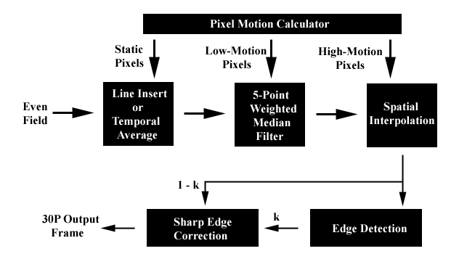
Figure 3: Block Diagram of Initially Proposed Algorithm.

SPECIFIC SUBPROBLEMS
As will be described later, there are many sum-of-absolute-difference (SAD) thresholds required to make the Simonetti de-interlacer robust for all input video sequences. For example, there is an obvious tradeoff when setting thresholds for what should be considered a static pixel due to different amounts of pixel noise with different color content of the frames. Additionally, the motion detector thresholds can be calibrated using one sequence, but then different threshold values might do better in other sequences. One other problem associated with comparing the accuracy of the de-interlacing thresholds is that the quality of the resultant video sequence cannot be easily determined by a single or even a few parameters. The quality largely depends on what is pleasing to the complex human visual system.

Another problem I faced was just with the implementation of the EDDI algorithm. An initially reconstructed image can be seen below in Figure 4, which is the input to the EDDI block. Figure 5 shows the resultant filtered image. As can be seen, the non-zero area around the zero-crossings in one line (transitions from black to white) can be compared to those of a neighboring line. If a close match is found, then interpolation can be applied along the relative orientation of the neighboring zero crossings to improve edge artifacts [3]. I had a difficult time implementing this relatively straightforward algorithm however, and thus implemented a slightly different edge-dependent algorithm.

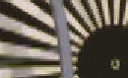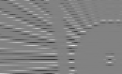
Figure 4: De-interlaced Input into EDDI Block.
Figure 5: Output after EDDI Prefilter.

FINAL ALGORITHM
Instead of correcting for edges after all other de-interlacing has been performed, I chose a method that selectively interpolated along edges found by the Canny method in the MATLAB Edge.m function before any of the Simonetti motion detection was performed. This choice was a direct result from experiments that interchanged the orders of interpolation and compared the resultant SAD values of the image produced with the original progressive source video. The high level description of the final algorithm can best be seen in the block diagram of Figure 6.

After edge detection, the edge interpolation is performed by first selecting a 1xN block centered about each interior pixel on a known field line. The size N has to be properly chosen because too large of a value will impede too many pixels from being interpolated, while too small of an N value will more than likely produce false positives instead of true
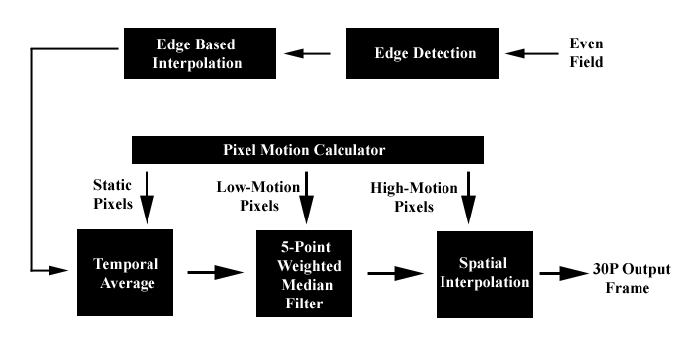
Figure 6: Block Diagram of Actual Implementation.

edges. Other factors include the weighting window given to the block and the proper selection of a threshold value which constitutes a found edge. Figure 7 below will help to graphically explain the interpolation performed. All pixel blocks on known data lines (white lines) of the current field are compared with the closest above and below known lines to find two best matches for each pixel. If the best match is different by less than a determined threshold, linear interpolation is performed. If the match happens to correspond to an inter-pixel location, a nearest neighbor approach is used. This could be more carefully analyzed in a future implementation.

The next step is to determine which pixels are static. Initially I thought that just comparing adjacent temporal pixels in the previous and following fields would be a good test for still pixels. It is possible however, to have relatively close values in the previous and following fields (P & N in Figure 8), and have a much different actual value in pixel X. This generally would occur if the current frame contained an image undergoing large

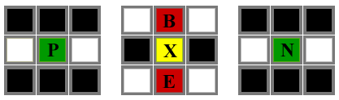
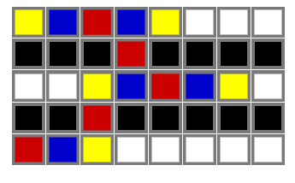
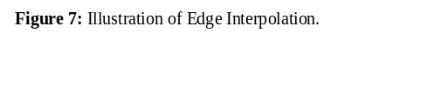
Figure 8: Illustration of Static Pixel Detector.
motions. To account for this discrepancy, Simonetti proposes to make sure that the luminance values of vertical neighboring pixels (B & E) are relatively close to the luminance of the temporally neighboring pixels (P & N). The following equations are used to determine if pixels are static [5].
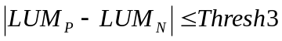
and
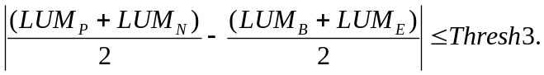

These “static” pixels are then filled into the unknown frame by either copying the data from the previous field or by using an average of the pixels in previous and following fields [5]. An averaging method will reduce noise and so that was the method implemented in my hybrid algorithm.

The algorithm next compares luminance of the I, J, K, and L pixels (seen in Figure 9) for the previous and following fields determine if relatively low motion has occurred. If the following equation

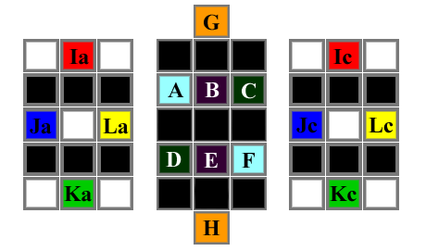
is satisfied with a properly selected threshold, the unknown center pixel can be determined using a five-point spatial median filter [5]. The average of the 4 color-coded pixel pairs serve as the first four inputs while the pixel pair that has the lowest sum divided by absolute difference will double as the fifth and final input to the median filter. Simonetti explains that this choice is based on the Weber law which states that the eye is more sensitive to small luminance differences in dark areas rather than in bright ones [5].
Figure 9: Illustration of Low-Motion Pixel Detector and median filter inputs.

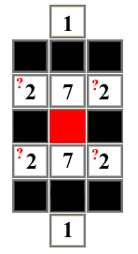
The last step of the algorithm is to fill in the remaining pixels, which are by default, the “high-motion” pixels. These pixels are likely to have little in common with previous or current fields and are thus interpolated purely in the spatial domain. I considered vertical interpolation using an h=[1, 0, 7, 16, 7, 0, 1]/16 filter known to have a better frequency response than just pure line averaging. I also considered including diagonal pixels to incorporate some of the horizontal dimension into the spatial interpolator (seen in Figure 10 with entries of 2). I was not able to conclude which interpolator performed better but hypothesized that the one including a horizontal component might slightly reduce edge artifacts.
Figure 10: Illustration of Possible Spatial Interpolation.

RESULTS
Although one would ideally prefer to view actual video footage processed by the hybrid de-interlacer, for the purposes of this report, still images must suffice. The following images will give the reader a very rough idea as to what quality the hybrid deinterlacer can achieve. Figure 11 below illustrates the first progressive frame of the input sequence Bicycle provided by Gerard de Haan. Both the bicycle wheel and the stripped pattern are rotating in a counter-clockwise direction.

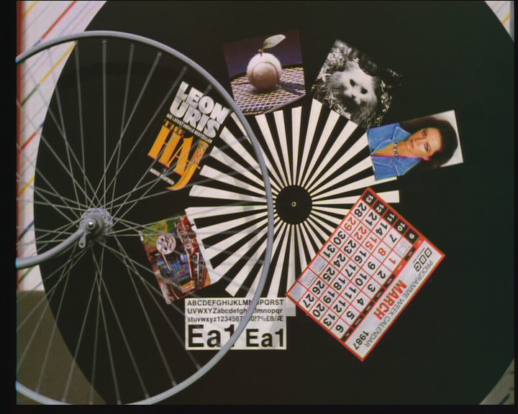
Figure 11: Original Frame from Bicycle Sequence.
The following figure illustrates the output of the hybrid method after all interpolations.
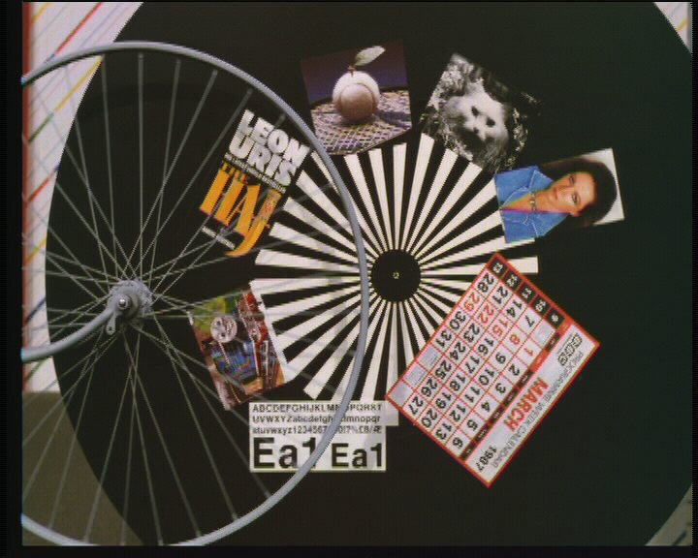
Figure 12: De-interlaced Frame from Bicycle Sequence.

Although these images cannot possibly show the artifacts necessary to determine how well the de-interlacer worked, the diagonal white lines on the spinning pattern do show some unnatural jagged edge artifacts on the near-horizontal diagonal lines.

COMPARISON
The results obtained from the hybrid algorithm perform about as expected. The output video sequences can in some cases rival more computationally expensive MC de-interlacers and can produce naturally occurring edges more effectively than some MC methods. When comparing this hybrid method with other Non-MC methods known to handle certain situations best, the difference in most cases is minimal. Specifically, the hybrid method can handle complex motion better than any other Non-MC method, handles still sequences the same as field merging, and performs slightly worse on horizontally moving scenes than a three-field median filter with majority selection. Other specific motion types were not compared, but high speed, random motion captured on the GL1 in Frame Mode was matched very well with the edge-enhanced hybrid de-interlacer.

CONCLUSION
Overall, the implemented algorithm achieves high quality output video with a cinematic feel but, still with some unnatural edge artifacts. These artifacts stem from not being able to extend the block matching edge search too far in either direction if some type of high frequency vertical pattern is present in the footage. This type of pattern would yield inaccurate edge detection and might interpolate along an unwanted direction. A future implementation would incorporate de Haan’s EDDI algorithm to further suppress these unwanted artifacts. Overall the implementation was relatively straightforward, but since there are so many free threshold parameters, it is difficult to calibrate the algorithm to work extremely well for all video sequences.

Future improvements in the algorithm include a tweaking of the threshold parameters, more efficient MATLAB optimization, and then possibly a conversion into C++ so that fast de-interlacing can be achieved. Overall this project was a fun and rewarding means to learn about current de-interlacing research, to learn more about different video formats, and to obtain some practical experience in the field of video signal processing.

REFERENCES
[1] G. de Haan, `Video processing for multimedia systems', ISBN: 90-9014015-8, Eindhoven Sep. 2000.
[2] G. de Haan and E.B. Bellers, ‘De-interlacing -- An overview', Proceedings of the IEEE, Vol. 86, No. 9, Sep. 1998, pp. 1839-1857.
[3] G. de Haan and R. Lodder, `De-interlacing of video data using motion vectors and edge Information', Digest of the ICCE'02, Jun. 2002, pp. 70-71.
[4] Beale, John, ‘Canon GL1 Notes and Observations’, John Beale's Home Page http://www.bealecorner.com/gl1/res/gl1res.html, May 2000.
[5] R. Simonetti, S. Carrato, G. Ramponi and A.Polo Filisan, 'Deinterlacing of HDTV Images for Multimedia Applications', in Signal Processing of HDTV, IV, E. Dubois and L. Chiariglione, Eds., Elsevier Science Publishers, 1993, pp. 765-772.
[6] Y. Wang, J. Ostermann, and Y.Q. Zhang, ‘Video Processing and Communications’ Prentice Hall, 2002, ISBN 0-13-017547-1.

